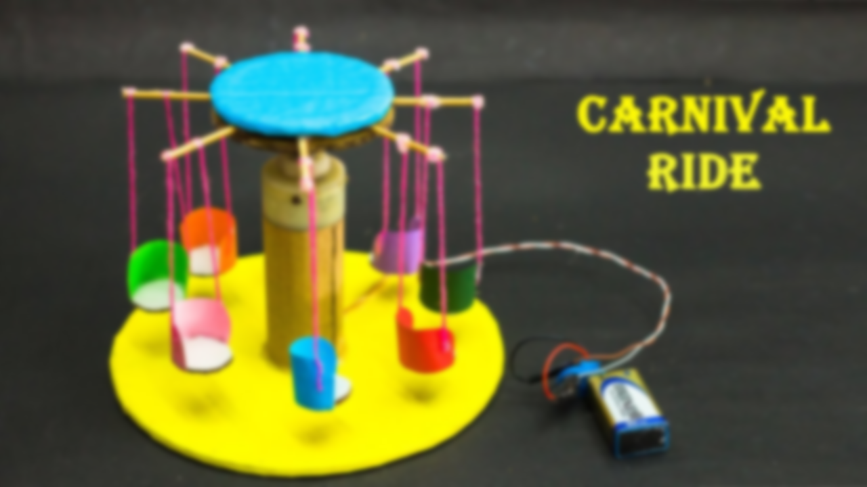

**Vocabulary**

**Components:** a part of a larger whole.

**Rotation:** spinning movement.

**Research:** find something out thoroughly.

**Embellish:** make something attractive by decorating it.

**Evaluate:** assess or sum up a project based on its successes and improvements.

**Final Piece: A moving fairground ride.**

I can create a moving miniature fairground ride.

* Complete the construction of the fairground rides, ensuring that it uses a motor to include a rotation motion.
* The design should include a decorative element which is informed from the research.
* Evaluate the design and make adjustments to it. Write a written evaluation to reflect your choices.
* ***Critique your work. Does your design meet the brief? What do you like about it? What would you change? How?***

**Learning point 4: Circuit components**

I can create an electrical circuit for my design.

* Refer to learning point 2 and create a simple circuit which includes a motor, battery, and switch.
* Discuss what happens when more components are added – power is reduced. Children can add lights to their circuits.
* Start constructing the final designs, referring to the sketch from learning point 3.

***Build a circuit and start constructing the final design around it.***

**Learning point 3: Final design**

I can refine an idea based on research.

* Children produce a final design with a rotation motion and incorporate the visual elements form the research in the first learning point.
* Discuss how a simple design can be embellished to look more attractive, sharing examples of modified carousels and big wheels.
* Share the video clip again and discuss how the design could be improved. Chn can consider adding lights to their design and circuits.

***Create a final design which is labelled and includes a list of materials required.***

**Learning point 2: Rotation with a motor**

I can explain how to create a circuit which includes a motor and switch.

* Show a variety of electrical circuits and discuss what their function would be. Identify key features including a motor and a switch.
* Identify fairground rides which use a rotation motion, including Ferris wheels, carousels, waltzers and chairoplanes. Share: <https://www.youtube.com/watch?v=AbalCeIxkOA>
* Design at least 2 rides which include this motion.

***Sketch at least 2 designs for an Oxford inspired fairground ride.***

**Learning point 1: Design research**

I can identify the design features of a fairground ride.

* Look at the purpose of the project: To create a moving fairground ride inspired by St Giles fair.
* Discuss how some rides work – drawing on scientific knowledge of rotation, forces, etc.
* Discuss the designs on rides -what tempts people to ride them?
* Complete a class survey on what they find appealing.
* Add three design sentences to respond to the brief:

***Make a miniature moving fairground ride, inspired by St Giles Fair in Oxford.***

**Previous Knowledge**

* Designing a product for a specific purpose
* Understanding that electric circuits can be incorporated into a design.
* Reflecting on the effectiveness of a design by evaluating it.

**Construction Materials**

**Fairground Rides**

