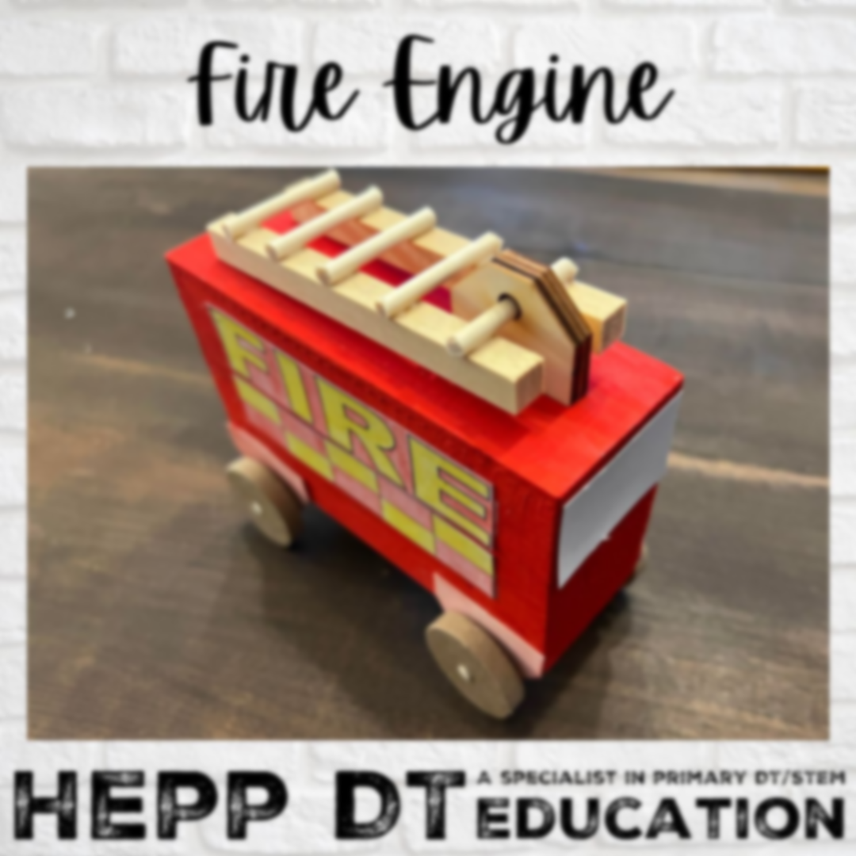

**Vocabulary**

**Design:** a drawing to show something before it’s made.

**Mechanism:** parts which work together.

**Construction:** the action of building something, usually a structure.

**Evaluate:** assess or sum up a project based on its successes and improvements.

**Final Piece: A moving fire engine toy.**

I can create a toy fire engine which moves.

* Review the designs from the previous week.
* Continue to paint and decorate the final design to make it look like a fire engine.
* Add a moving feature using a split pin (ladder or hose, for example).
* Critique the design against the design brief, evaluating its effectiveness and style.
* ***Critique your work. Does your design meet the brief? What do you like about it? What would you change? How?***

**Learning point 1: Design research**

I can identify the design features of a moving toy.

* Look at fire engines from 1666 and today and identify some key features of both.
* Discuss how they move and other features that will move or function on them.
* What shapes can we see and what objects could we use to make a toy fire engine?
* Record some of this information in a sketchbook.
* Present the design brief in sketchbooks:

***Make a moving fire engine toy which can be played with by a 5-7 year old.***

**Learning point 3: Joining card and paper**

I can join paper and card using glue, split pins and tape.

* Discuss which fastenings would be best for joining paper to paper/card.
* Use a template to create a simple cuboid model and join the edges.
* Start to design the decoration of the toy in sketchbooks.

***Create a simple cuboid fire engine which is joined using glue, tape and includes a split pin fastening.***

**Learning point 4: Designing the vehicle**

I can create an appropriate design for a moving fire engine toy.

* Review the research from the first week.
* Decide which fire engine would be more appealing for children to play with.
* Create a final design in your sketchbooks and label the design with colours, materials and features.
* Start to decorate the cuboid design from the previous session.

***Decorate the fire engines to look either contemporary or historic.***

**Learning point 2: Axles and wheels**

I can explain how wheels and axles can allow a toy to move.

* Look at a variety of different toy vehicles and discuss the moving parts.
* Identify the wheels and axles on all of the toys and discuss how they are held in place.
* Sketch the mechanism and consider how to join them to your design.

***Sketch an initial design, highlighting the wheels and axles and where they will be attached to enable movement.***

**Previous Knowledge**

* Modelling with a range of materials in Early Years.
* Understand that toys can replicate real objects.
* Materials have different properties.

**Mechanisms and Materials**

**Moving Fire Engines**

