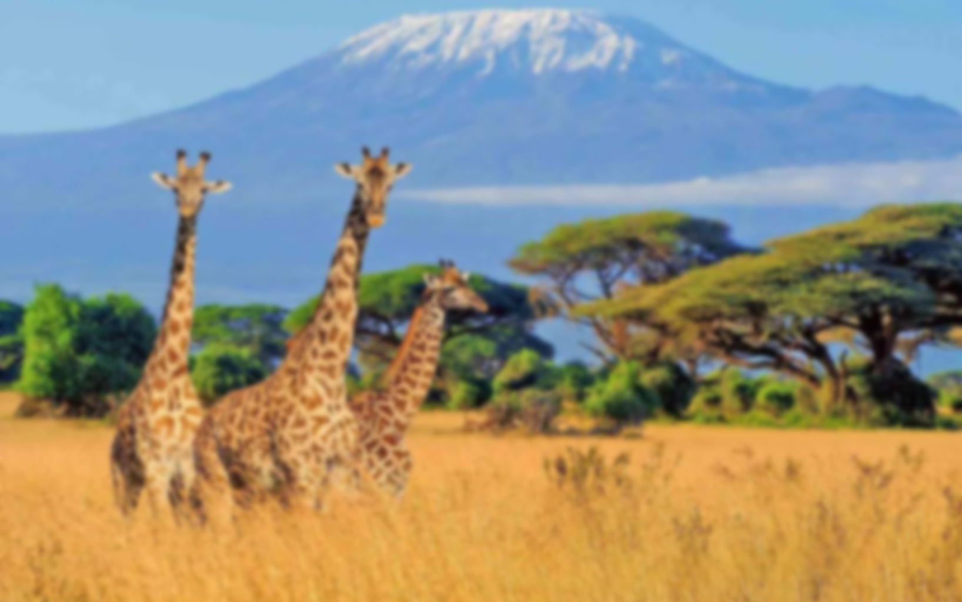

**The Big Topic Question:**

**What can we learn about ourselves by studying other cultures?**

*How has trading with Africa and learning about different cultures and traditions changed our lives in Long Hanborough? How has it enriched our lives?*

* Use all the previous learning points to determine how much our country has benefited from its relationship with Africa. Discuss and clarify any misconceptions.
* Produce an information text to explain your answer to the Big Topic Question.

**Learning point 2: Exploration of Africa**

I can explain how explorers have helped us to learn more about a different continent

* Share a simplified version of the exploration of David Livingstone and Mary Kingsley.
* Trace their path of exploration on a map and question what it was like to explore a new place for the first time.
* Discuss hardships and make a simple boardgame to summarise the excitement and dangers of exploration.

***Why is it important that explorers share their experiences with other people?***

**Learning point 3: The Suez Canal.**

I can explain why the Suez Canal is important to world trade

* Define what a canal is and why the Suez Canal was built.
* Create mini-barges to carry ‘cargo’ from one place to another by travelling on the canal.
* Look at the impact caused when the canal became blocked in 2021.

***Why is the Suez Canal so important for world trade routes?***

**Learning point 1: Trade between Africa and the UK**

I can explain the importance of trade between African countries and the UK

* Explain what trading is and identify which goods are traded between both African countries and the UK.
* Simulate the trading of goods and explore how long trade between these countries has been going on.
* Learn how trade first began, and how we can learn from past mistakes.

***How has trade with Africa impacted our lives today?***

**Vocabulary**

**Exploration:** Going to new places to discover and learn about them.

**Explorer:** A person who travels to new and unknown places to learn about them.

**Cultural Exchange:** Sharing and learning about each other's customs, traditions, and ways of life. When people from different places trade, they also share a bit of their culture.

**Goods:** Things that people make or grow, like toys, food, or clothes. During trade, people exchange goods to get what they need or want.

**Previous Knowledge**

* Understands how past events and actions can affect our world today.
* Understand that some foods are grown in hot countries and others are grown in colder countries.
* Understand how we learn about places and events from primary sources, like diary entries.

**Key Concepts**

* **Trade:** exchanging of goods, services, ideas and cultures with others.
* **Culture:** the arts, ideas, customs, and social behaviour of a particular people or society.

**Amazing Africa**

**Comparing the UK and Africa**