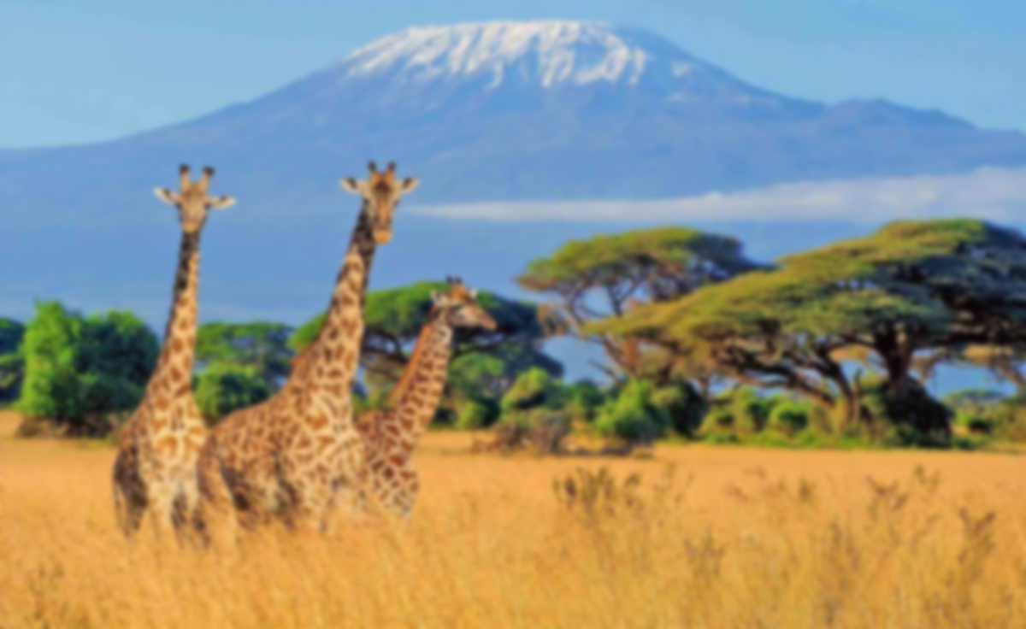

**Vocabulary**

**Diversity:** The presence of different cultures, languages, and traditions within a community.

**Continent:** A large landmass, and Africa is the second largest of the seven continents on Earth.

**Tradition:** A custom or practice that has been passed down from generation to generation.

**Market:** A place where people buy and sell goods, often a central part of trade.

**Ethnicity:** The cultural identity and heritage shared by a group of people.

**Heritage:** The cultural, historical, or natural aspects that are passed down through generations.

**Learning point 5: Folktales and Stories**

Explain how stories share and celebrate cultural values.

* Identify a traditional story from the UK (Robin Hood) and one from Africa (Anansi the Spider).
* Discuss the morals and the traditions seen in both stories.
* Children create a simple puppet show and recreate the stories.
* Summarise how cultural values are celebrated in each story.

***How do stories help to share cultural ideas and traditions between generations?***

**Learning point 4: Cultural celebrations in the UK and Africa**

Compare the cultural celebrations in the UK and Africa.

* Look at Christmas, Bonfire night, Kwanzaa and Diwali.
* Discuss what the events celebrate and how people celebrate them.
* Create a Venn diagram to identify similarities and differences between all four celebrations.

***Why is it important to acknowledge and show respect to other cultures and their traditions?***

**Learning point 3: Long Hanborough and Franschhoek.**

Compare a village in the UK to a village in Africa.

* Locate each village and look at the physical landscape of both.
* Identify the importance of agriculture to both villages.
* Discuss both being community based compared to urban centres.

***How are Long Hanborough and Franschhoek similar and different?***

**Learning point 2: Landscapes and Habitats.**

Identify the physical geography of England and Kenya and some key flora and fauna of each.

* Look at the weather patterns and temperature of the UK and Kenya.
* Identify some of the main wildlife of each.

***Why are some animals and plants native to Africa and not the UK?***

**Learning point 1: Continents and Oceans.**

I can locate the continents and oceans on planet Earth.

* Use a large map to locate the continents and oceans on planet Earth.
* Locate Long Hanborough and the capital cities of the countries in the UK.
* Locate some countries within Africa, identifying their capital cities

***What’s the difference between a country and a continent?***

**Key Concepts**

* **Trade:** exchanging of goods, services, ideas and cultures with others.
* **Culture:** the arts, ideas, customs, and social behaviour of a particular people or society.

**Previous Knowledge**

* Understand the difference between a village and a city.
* Know that London is the capital of England.
* Know the UK is made up of 4 countries.
* Understand weather patterns of the seasons in the UK.

**Amazing Africa**

**Comparing the UK and Africa**