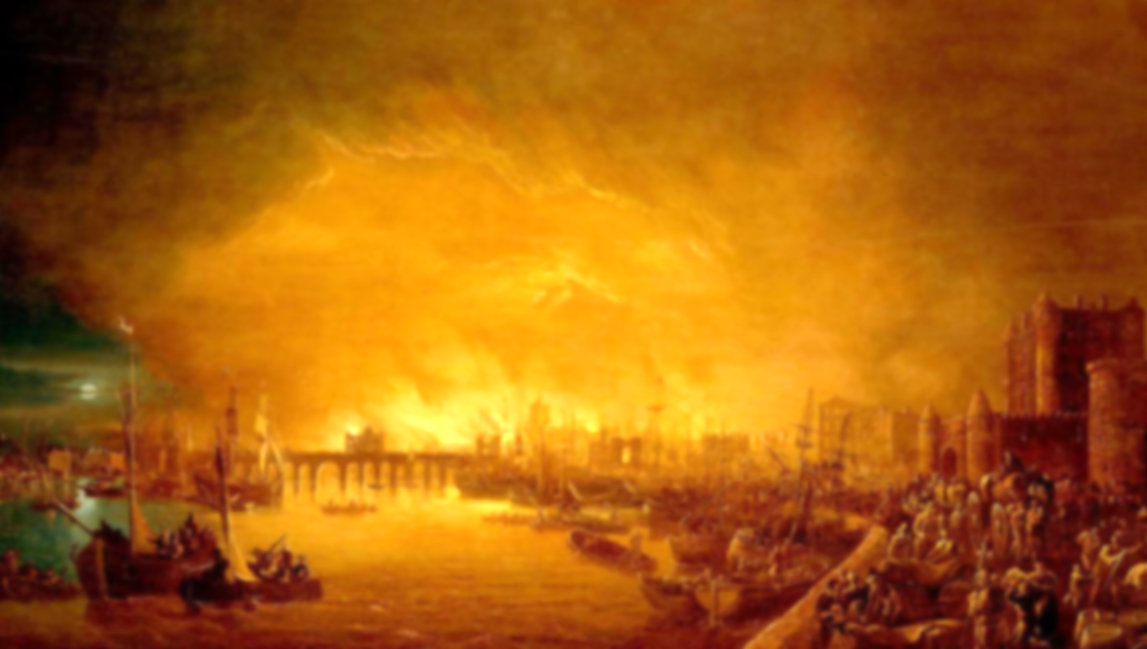

**Learning point 3: Did seasonal weather contribute to the fire?**

To understand typical weather patterns of the four seasons

* Idenitfy typical weather patterns for each season.
* Understand how the wind can contribute to the spread of fire.
* Discuss how other factors, including physical geography, could help the spread of fire.

***Would the fire have spread if it was Winter?***

**Learning point 2: Hanborough vs. London.**

To know and understand the differences between a village and city

* Look at London and Hanborough on maps, aerial photographs and Google Earth.
* Identify physical features including rivers, mounds, forests, etc. Identify human features including shops and train stations.
* Find out population of both London and Hanborough.
* Define hamlet, village, town and city and identify which London and Hanborough are.

***What similarities do London and Hanborough have?***

**Learning point 1: London – then and now.**

I can identify how London has changed over time

* Explain that there are four countries that make up the British Isles. Identify the capital cities of each.
* Focus on London being the capital of England.
* Compare London in 1666 to today using pictures and aerial photographs. Notice what has changed.

***How has London changed over the centuries?***

**Vocabulary**

**Country:** a nation with its own government

**Capital:** the city where the government is based

**City:** a large town

**Village:** a group of houses in a rural area

**Rural:** the countryside

**Physical features:** the natural part of the world

**Human features:** the part of the world build by humans

**The Big Topic Question:**

**Could there be The Great Fire of Hanborough?**

*Could there ever be a Great fire of Hanborough, and if there was, would it be as devastating as The Great fire of London?*

* Use all the previous learning points to determine whether a fire of this scale could take place in our village.
* Discuss and clarify any misconceptions.
* Produce an information text to explain your answer to the Big Topic Question.

**Key Concepts**

* **Community:** a group of people living in the same place or having a particular characteristic in common.
* **Culture:** the arts, ideas, customs, and social behaviour of a particular people or society.

**Fire! Fire!**

**The Great Fire of London**

**Previous Knowledge**

* Have an understanding of human features of Long Hanborough (shops, museum, etc.)
* Have an understanding of some physical features including the river.