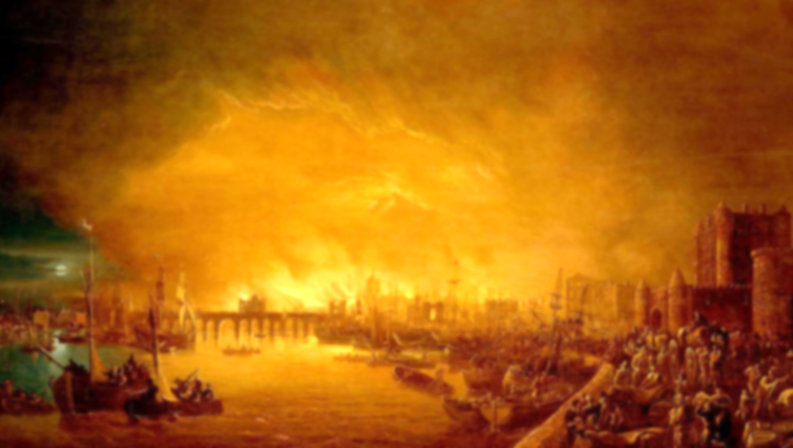

**Vocabulary**

**Century:** 100 years

**Eyewitness:** a person who has seen something happen

**Significant:** important or noteworthy

**Source:** something where information can be obtained

**Plague:** a highly contagious disease

**Flammable:** easily set on fire

**Declaration:** a formal statement or announcement

**Architect:** someone who designs buildings

**Monarch:** the king or queen

**Thatch:** a roof covering of straw

**Learning point 5: What lessons have we learned from the Great Fire of London?**

To understand key features of events, choosing and using parts of stories and asking and answering questions.

* Elicit the children’s understanding of The Great Fire of London, and the events which led up to it, during it and after it.
* Discuss changes which took place directly afterwards.
* Which of these changes can we still see today?

***How did the community of London pull together and support each other during the Great Fire of London?***

**Learning point 4: What happened after the Great Fire?**

To understand some of the ways in which we find out about the past and identify different ways in which it is represented.

* What measures were put in place to stop the fire spreading?
* Should London be built the same as it was before?
* Hotseat King Charles II on his plans for London after the fire.

***What should King Charles II do differently when rebuilding London?***

**Learning point 3: How do we know about the Great Fire of London?**

To understand some of the ways in which we find out about the past and identify different ways in which it is represented.

* Use paintings and Samuel Pepys’ diary to learn more about the fire.
* Discuss the reliability of different sources of information.

***Is Samuel Pepys’ diary a reliable source?***

**Learning point 2: Events leading up to the fire.**

To know and understand key features of an event beyond living memory that are nationally significant.

* Order the events of the Great Fire of London on a timeline.
* Understand the cause of the fire and how it spread so rapidly.

***Was the fire started through a lack of responsibility?***

**Learning point 1: Life in 17th Century England.**

I can identify differences and similarities between ways of life in different periods (now and 1666).

* Explain how people live now is different to how people lived in 1666 by looking at jobs/roles in daily life.
* Use sources (paintings) to notice differences in buildings.
* Think about living conditions – diseases, dirt, plague doctors, rats, etc.

***How was life in 1666 different to today?***

**Key Concepts**

* **Community:** a group of people living in the same place or having a particular characteristic in common.
* **Culture:** the arts, ideas, customs, and social behaviour of a particular people or society.

**Fire! Fire!**

**The Great Fire of London**

**Previous Knowledge**

* Understand family and the people around you.
* Used art as a way of communication.
* Understand that we follow rules or behave in a certain way in different situations.