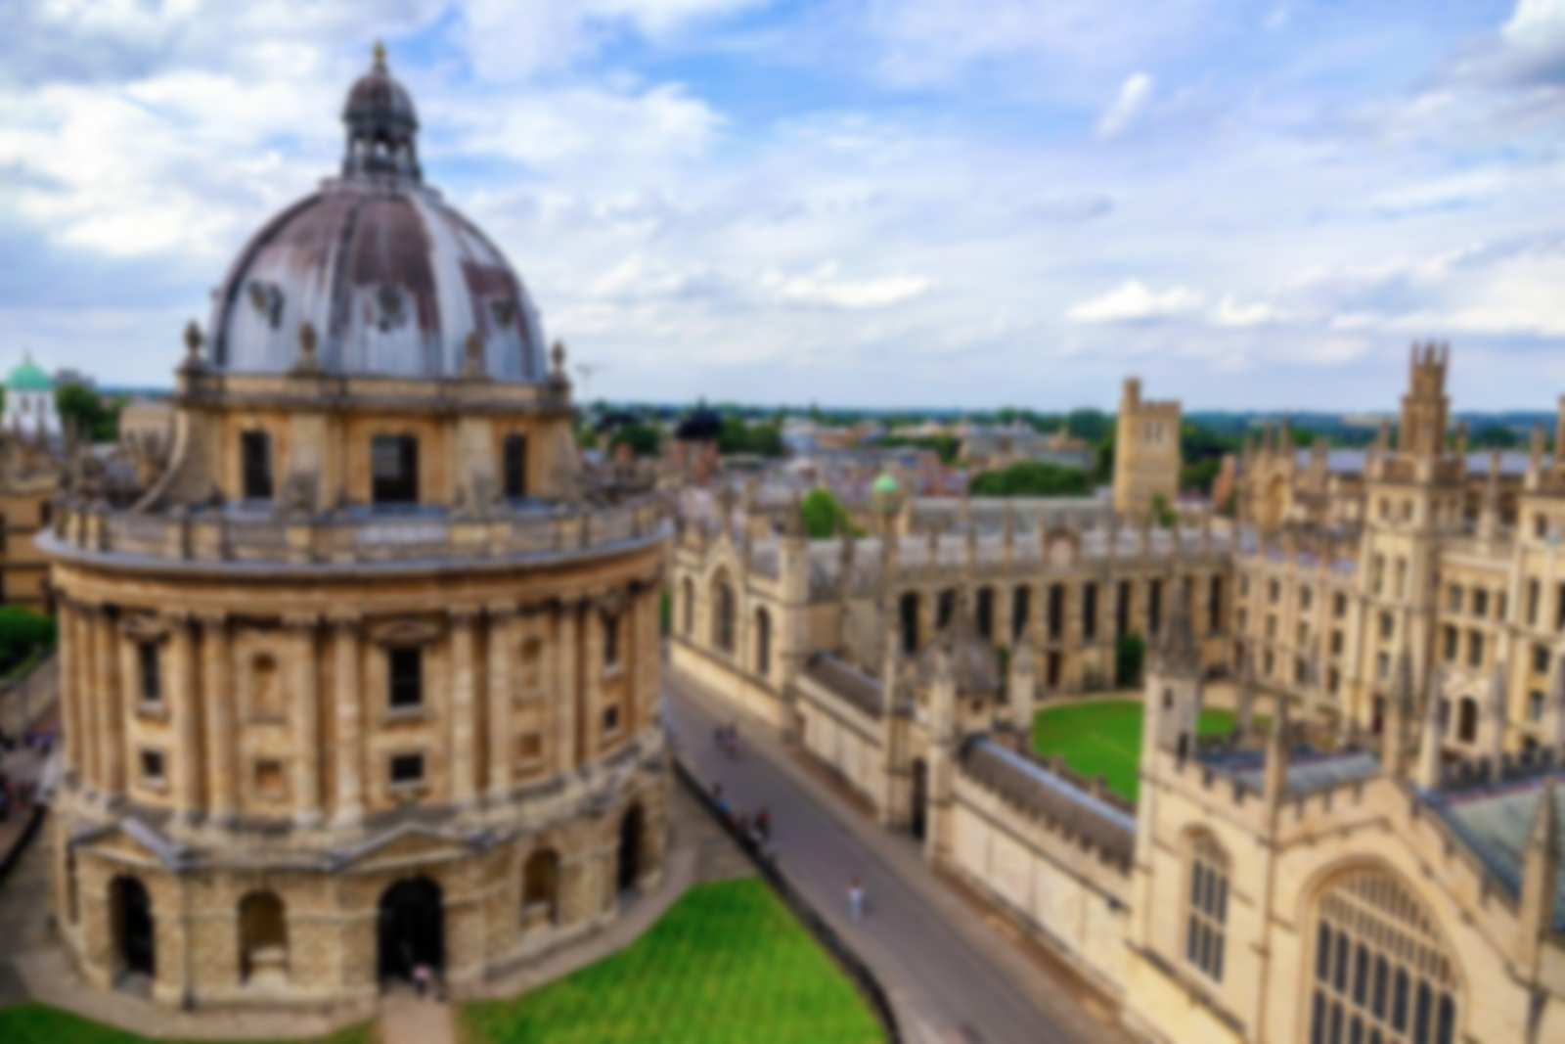

**Vocabulary**

**Floodplain:** An area of low ground next to a river, formed mainly of river sediments and subject to flooding.

**Sustainability:** ways of helping look after our planet for future generations.

**Urbanization:** The process by which towns and cities are formed and become larger.

**Landmarks:** An object or feature of a landscape that is easily seen and recognized.

**Physical Geography:** natural features and processes.

**Human Geography:** how human activity affects or is influenced by the earth's surface.

**The Big Topic Question:**

**How important will Oxford be in the future?**

*Will Oxford still be important academically, and as a growing city in the distant future? How has its past helped to inform your decisions?*

* Use all the previous learning points to determine whether the university and growth of the city will continue to be important to the UK.
* Discuss and clarify any misconceptions.
* Produce an information text to explain your answer to the Big Topic Question.

**Learning Point 3: The urbanisation of Oxford**

I can trace the changes of the city of Oxford over time and predict future changes.

* Use aerial maps to see how the city has changed over the last 100 years.
* Compare with London, using the same time frame and spot trends and influences for growth.
* Identify some human geographical features, including key sites such as Oxford Castle, Radcliffe Camera, Bodleian Library, Sheldonian Theatre and Bridge of Sighs.

***How has the city changed over the last 100 years?***

**Learning Point 1: Rivers & Waterways**

To understand the role of the river Thames in the growth of the city.

* + Trace the waterways through Oxford and beyond.
  + Explore the role and significance of the River Thames, River Cherwell, and Oxford Canal in the city's history and daily life.
  + Understand what a floodplain is and how Oxford's location impacts the city, and the challenges of managing flooding.
  + Examine the importance of these waterways for transport, commerce, recreation, and biodiversity.

***How have the rivers and waterways shaped Oxford and its history?***

**Incredible Oxford**

**The History & Geography of the City of Oxford**

**Learning Point 2: Oxfordshire the county**

To identify Oxfordshire and other counties within the UK.

* Identify Oxfordshire on a map of the UK.
* Look at the other home counties around Oxfordshire.
* Trace the river Thames and its tributaries through different counties.
* Understand why the counties are named after a specific town or city (Oxford naming Oxfordshire for example).

***Why is the county of Oxfordshire named after the city of Oxford?***

**Previous Knowledge**

* Naming the capital cities of the UK and the country’s wider location globally.
* Prior experience of using an atlas and a globe. Use of geographical digital imaging such as Google Earth.
* An understanding of human and physical geography.

**Key Concepts**

* **Monarchy:** the role and impact of kings, queens, and royal families in shaping societies, politics, and global relations.
* **Culture:** the arts, ideas, customs, and social behaviour of a particular people or society.