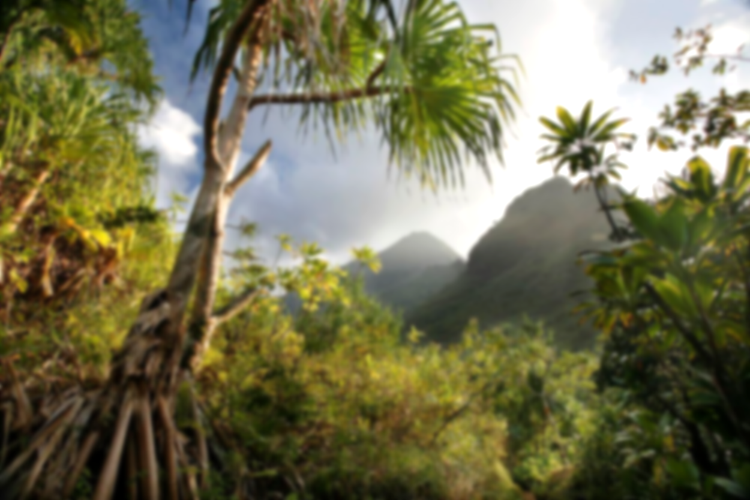

**The Big Topic Question:**

**Would planet Earth be the same without rainforests?**

*How different would our world be without rainforests? Would it even exist? How will deforestation impact our future?*

Use all the previous learning points to determine whether our world would be the same without rainforests. Discuss and clarify any misconceptions.

Produce an information text to explain your answer to the Big Topic Question.

**Learning Point 1: Historical Civilizations within Rainforests**

I can understand and discuss the ancient civilizations and tribes that inhabited rainforests, their ways of life, and their practices.

• Explore historical civilizations within rainforests, such as the Maya (Central America), the Khmer Empire (Cambodia) and the Kingdom of Ife (Africa).

• Understand how societies adapted and interacted with their environment, including their use of plants for food, medicine, and materials.

• Reflect on what these civilizations can teach us about living in harmony with nature.

***Who were the ancient civilizations that lived in rainforests and how did they interact with their environment?***

**Learning Point 3: Colonial Impact on Rainforest Civilizations**

I can understand and discuss the impact of colonialism, with a particular focus on the role of the Conquistadors, on rainforest civilizations.

• Examine the arrival and actions of the Conquistadors in Central/South America, and their impact on civilizations there.

• Discuss how colonialism led to the disruption of indigenous societies, land use patterns, and introduction of diseases.

• Reflect on the long-term effects of these changes, including loss of cultural heritage, decrease in biodiversity and alteration of the rainforest landscape.

• Explore the stories and historical sources of colonial explorers of the rainforests (Francisco de Orellana, Henry Walter Bates etc…)

***What key changes happened because of colonialism?***

**Learning Point 2: Historical Use of Rainforests**

I can understand and discuss how rainforests have been utilized throughout history for various resources and necessities.

• Explore the different resources that rainforests have provided, such as timber, rubber, fruits, nuts, and a diverse array of medicinal plants.

• Understand how ancient civilizations harnessed these resources for their needs, from building materials and food to healing remedies.

• Discuss how the use of these resources were traded with cultures and communities around the world (cocoa, coffee, rubber, vanilla, teak and mahogany woods etc…)

• Reflect on the balance between resource extraction and sustainability, and the impact on rainforests over time.

***What resources have rainforests provided throughout history and how have they been used?***

**Jungle Fever!**

**Rainforests around the world**

**Vocabulary**

**Civilization:** the way of life, arts and religions of particular people in an area.

**Resources:** the money, equipment and supplies in an area.

**Remedy:** medicine to cure illness or disease.

**Colony:** A group of people living in a foreign place.

**Conquistador:** A Spanish conqueror.

**Previous Knowledge**

* Chronological Understanding of the passage of time, including key periods in history.
* Pupils should be able to comprehend some key characteristics of past societies and historical periods.
* Pupils have some experience interpreting historical sources (images, artifacts, or texts) to gather information about the past.

**Key Concepts**

* **Trade:** The exchange of goods, services, ideas and cultures, and how this has shaped economies, societies, and global relations.
* **Culture:** The arts, ideas, customs, and social behaviour of a particular people or society.