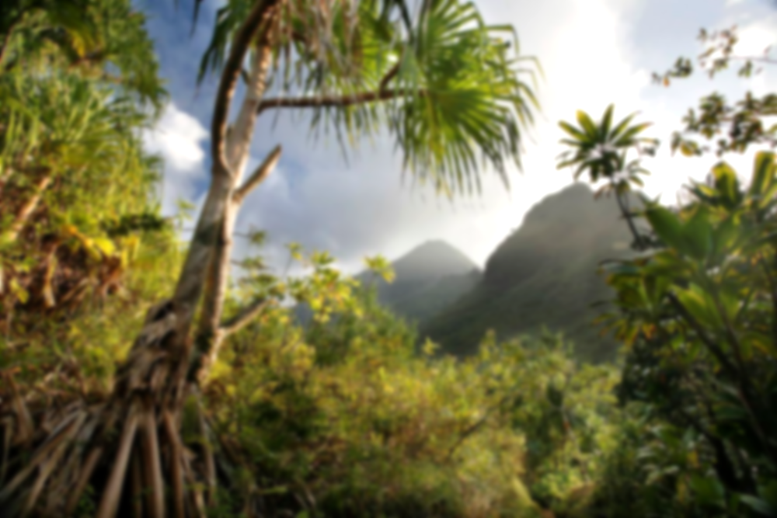

**Jungle Fever!**

**Rainforests around the world**

**Vocabulary**

**Canopy:** The upper layer of the rainforest where the tops of tall trees form a kind of roof.

**Understory:** The layer of the rainforest below the canopy, where plants grow in the shade.

**Forest floor:** The lowest layer of the rainforest, where decomposed leaves and dead plants provide nutrients for the soil.

**Equator:** An imaginary line around the middle of the Earth, at an equal distance from the North Pole and the South Pole.

**Biodiversity:** The different types of plants and animals that live in a place.

**Deforestation:** Cutting down trees to clearing forests.

**Conservation:** The process of protecting the environment and preserving it for the future.

**Learning point 5: Deforestation**

To understand why the rainforest is being cut down and the effects it has on our lives.

* Identify some of the reasons for deforestation.
* Understand why it is important to protect the rainforest.
* What is our role, in Long Hanborough, in protecting the rainforests (palm oils, recycling, etc.)

***What can we do to help protect the rainforests?***

**Learning point 2: Layers of the rainforest.**

To understand that rainforests have distinct layers to their growth.

* Identify the four different layers of the rainforest.
* Look at the characteristics of each layer and draw a cross section of the rainforest.
* Identify the flora and fauna of each layer.

***What are the four layers of the rainforest called?***

**Learning point 3: Creatures of the rainforests**

To examine the animals that make the rainforest their home.

* Build upon knowledge from the last session in terms of what creatures live in each layer of the rainforest.
* Understand how animals have evolved to suit their habitat.
* Focus on one creature and produce a non-chron report.

***Why are some creatures only found in the rainforest?***

**Learning point 4: Humans and rainforests**

To look at how humans use the rainforests today.

* Name some of the ancient and modern tribes that live in the rainforest.
* Understand how their lives are different to ours.
* Look at how there are pressures to cut down rainforests.

***Do all communities on earth live like our community in Long Hanborough? Explain.***

**Learning point 1: Rainforest climates.**

I can identify rainforests around the world and explain why they are found there.

* Use an atlas and map to identify the major rainforests.
* Look at the importance of the equator and the tropics.
* Examine the typical weather conditions, temperature, rainfall of a rainforest compared to Hanborough.

***Why are rainforests located near the equator?***

**Previous Knowledge**

* Understand human features of Long Hanborough (shops, museum, etc.)
* Understand some physical features including the river.

**Key Concepts**

* **Trade:** The exchange of goods, services, ideas and cultures, and how this has shaped economies, societies, and global relations.
* **Culture:** The arts, ideas, customs, and social behaviour of a particular people or society.