KS2 KCV –Topic: Local Study (Oxford and Cassington)
Key Skills | Description
Using maps and atlases | Being able to locate Cassington and other local villages, towns and cities in the UK.  To locate counties, including Oxfordshire, in the UK.
To use OS maps and symbols | Being able to locate features using basic OS symbols & 4 figure grid referencing
Describe key human and physical features | Being able to describe human and physical features locally (including hills, mountains, coasts & rivers).  Understand changes over time
Use field observations | Describe changes to the landscape over time

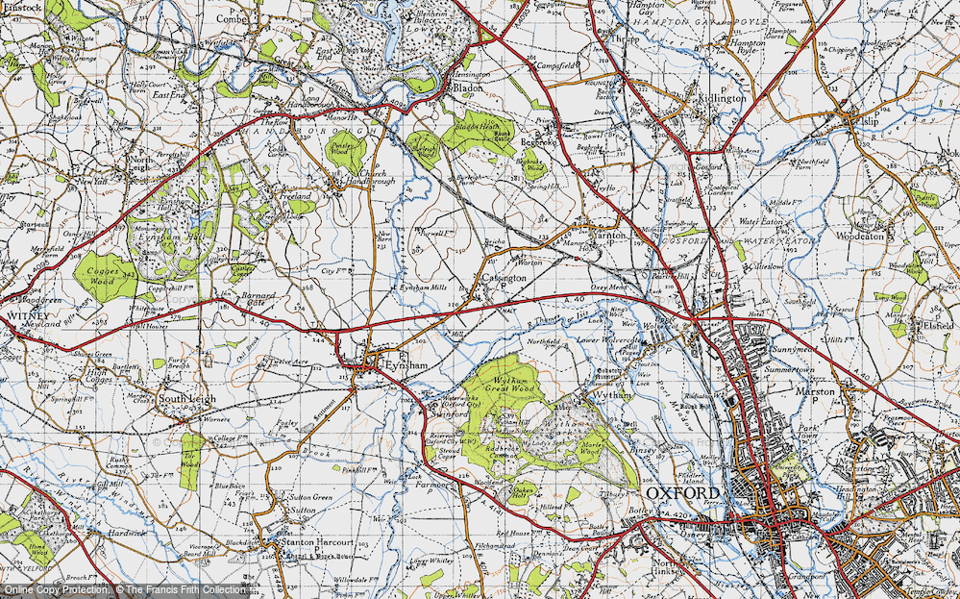
High Frequency Vocabulary
country  county  town  village  city | symbol  location  coast  rivers

Key Concepts/ Questions
Which continent, country, county and town/village do I live in?
What is the land in my area used for?
What is the nearest city and how is it the same /different to Cassington?
How and why are symbols used on maps?
How has my area changed over time?
Can I describe human and physical features locally?

Key Vocabulary
Ordnance Survey (OS) grid references: the UK is covered by a grid of maps that are given letters. A grid system of numbers are used to locate places on each map.
Capital city: the primary city in a country.
Compass directions: North, South, East, West
Rural: relating to the countryside.
Suburb: a development at the edge of a city.
Urban: relating to a town or city.
Human characteristics: the human characteristics of a place come from human ideas and actions e.g they include bridges, houses and parks.
Physical characteristics: the physical characteristics of a place are its natural environment e.g rivers, mountains.

