Subject Specific Vocabulary (Tier 3)
Species  Deforestation  Emergent layer | A group of similar animals or plants.  The action of clearing a wide area of trees.  Giant tress that enjoy the most sun but this layer has high winds & can be cold. Birds, bats and butterflies live in the tops of these tall trees.
Canopy layer | Dense layer of trees overlapping each other. Home to most animals in rainforests.
Understorey layer | Relatively dark, open area below the canopy. In these lower branches you can find snakes and red‐eyed tree frogs.
Forest Floor | Mainly consisting of fallen leaves, fruit etc. that decomposes as food for trees.  The ground layer of the forest is full of insects and home to the biggest animals of the rainforests such as jaguars.
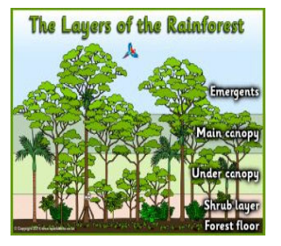
KS2 Geography KCV – Rainforests
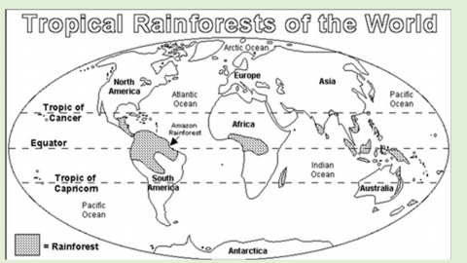

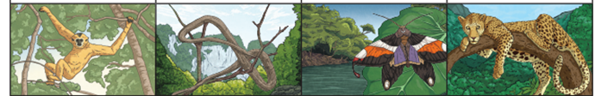

High Frequency Vocabulary (Tier 2)
rainforest  Amazon  climate | layer  tropical  humid | equator  habitat  animals

Key Concepts
Around 80% of the food we eat originally came from rainforests.
E,g bananas, chocolate, rice, coffee.
Rainforests are found near the equator.
6% of the Earth’s surface is covered in tropical rainforests and is home
to over half the world’s total plant and animal species.
Over ¼ of the medicines we use today had their origins in the
rainforests.
The Amazon Rainforest produces more than 20% of the world’s oxygen.

Global Citizenship
Exploring and explaining the effects humans are having on rainforests.
Identify the positive and negative effects of deforestation.
Key Concept Questions
What is a rainforest?
Where are the rainforests in the world?
What are the layers of the rainforest?
What creatures /animals live in the rainforest?
What is the world’s largest rainforest?
What are the largest threats to rainforests?
How can we protect the rainforests of the world?

