Subject Specific Vocabulary
Volcano: A mountain or hill with a crater where lava, rock fragments, hot vapour and gas are or have erupted from the earth’s crust.
Earthquake: A sudden violent shaking of the ground, that can cause destruction as a result of movement within the earth’s crust or volcanic action.
Tornado: A giant tube of air that spins violently from a thunder cloud.
Tsunamis: Large, powerful waves that grow in size as they reach the shore.
Tectonic plates: Broken pieces made of the earth’s crust.
Dormant: In a state of rest. A volcano that is quiet, but might erupt again.
Extinct: The dying out or disappearance. A volcano that has not erupted in 10,000 years.
Active: A volcano that has recently erupted and may erupt again soon.
Eruption: A sudden explosion sending out lava, rocks and ash.
Magma: Molten rock that is found below the earth’s surface.
Subsoil: This soil is full of nutrients with rocks in clay. Tree roots may reach into this soil. You might find fossils here.
Crust: The thin outer layer of cold, hard rock that covers the Earth.
Mantle: The second layer of the earth. It is extremely hot rock that often flows like treacle and is 3000km thick.
Outer core: The is the third layer of earth and is mostly made up of iron, with some nickel. It is over 4000˚C. it is mostly liquid with some rocky parts.
Inner core: The inside layer of earth. Is made of iron and nickel, is the hottest layer of the Earth at over 5000˚C.
Topsoil: Where plants grow their roots. There are very few rocks.
Bedrock: A mass of rock such as granite, basalt, quartzite, limestone or sandstone. You might find fossils here.
Flood: A rise of water with no place to go.
KS2 KCV –Topic: Extreme Earth
Key Skills | Description
To ask/initiate geographical questions, respond to questions and offer their own ideas. | To ask informed questions about volcanoes, earthquakes, tornadoes and tsunamis and offer explanations as to how they are caused.
To use NF books, stories, atlases, pictures/photos and internet as sources of information. | To explore personal recounts and photos of the four conditions and use these to consider the impact they can all have.
Analyse evidence and begin to draw conclusions.  Make comparisons between locations photos/pictures/ maps | To explore and compare different events and where they occur in the world.
Confidently use an atlas. Recognise world map as a flattened globe. | To locate different countries in the world where events occur and to notice any patterns.

High Frequency Vocabulary
Volcanoes  Earthquakes  Tornadoes  Tsunamis | Earth  Surface  Weather  Extreme | Climate  Soil
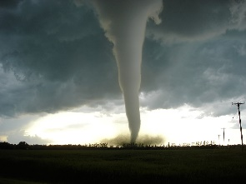
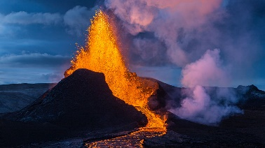
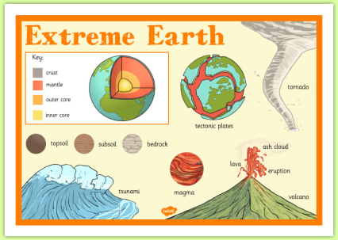
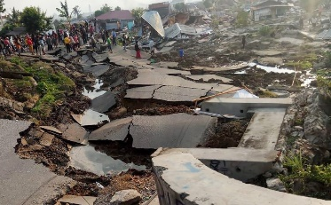
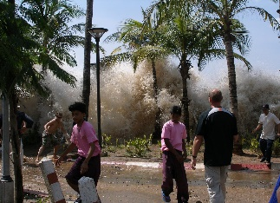
Key Concepts/ Questions
What is under the Earth’s surface?
How are volcanoes formed?
What impact can volcanoes have on the lives of humans?
How are earthquakes formed and how are they measured?
How are tsunamis caused and how can they affect people?
How are tornadoes caused and what effect can they have?
What is climate and how does climate affect the Earth?
What is extreme weather and what are the causes of extreme weather events?
What impact can extreme weather events have?

