KS2 History KCV – Stone Age
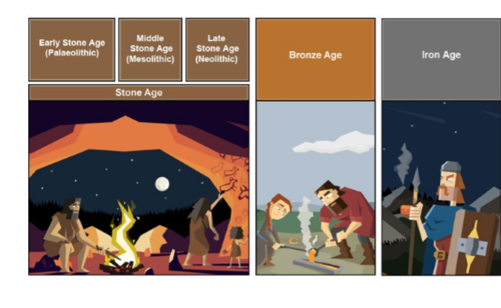
850, 000 BC Lower and Middle Palaeolithic

40,000 BC Upper Palaeolithic

10,000 BC Mesolithic started

4,000 BC Neolithic started

2, 300 BC Bronze Age started
700 BC Iron Age started

43 AD Roman Invasion

High Frequency Vocabulary (Tier 2)
Iron Age | tools | hunters
flint | Stone Age | farming
Bronze Age  continents | trading  Europe | weapons  agriculture

Key Concept Questions
What is the prehistoric period and when was it?
What was hunted and gathered to eat in the Stone Age?
How much did life change when man learned to farm?
What can we learn about life in the Stone Age from Skara Brae ?
What were their homes like in prehistoric times?
What was invented in the prehistoric period?
What changes occurred in the Bronze Age and Iron Age?

Subject Specific Vocabulary (Tier 3)
Palaeolithic | Early Stone Age people hunted with sharpened sticks. They used animal skins to make clothes and shelter
Mesolithic | Middle Stone Age people dug flint out of the ground, using antlers as a pick. They made weapons with which to hunt.
Neolithic | Around 6,500 years ago a change took place in the way Stone Age people lived: hunter-gatherers settled in one place and kept animals and grew crops
Prehistoric | The time in history between Stone Age and the first written records.
Hillforts | A type of settlement in the late Bronze Age and Iron Age that were often on hills with big defensive banks.
Skara Brae: | A well preserved Stone aged village in Orkney Scotland.
