Subject Specific Vocabulary (Tier 3)
Cartouche | An oval containing hieroglyphics with a horizontal line underneath indicating a royal name
Hieroglyphics | A writing system where picture symbols stood for meanings or sounds. It meant ‘sacred carving’
Sarcophagus | A stone coffin adorned with a sculpture or inscription containing a mummy.
Papyrus | A type of plant grown in abundance in ancient Egypt turned into a paper-like material for writing.
Canopic Jar | Jars with intestines, stomach, lungs and liver - all of which were thought to be needed in the afterlife.
Mummification  Dynasty | The process of preserving a body after death.  A period of rule when the pharaohs all came from the same family.
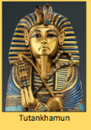
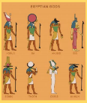
KS2 History KCV – Ancient Egypt
When? Key Knowledge
All dates are approximate
Old Kingdom  Middle Kingdom  New Kingdom | 2600 BCE- 2100 BCE  2000 BCE- 1650 BCE  1540 BCE- 1075 BCE
7500 BCE | First settlers in Nile Valley
3200 BCE | Hieroglyphic script used
2650 BCE | First step pyramid built
2550 BCE | Pyramids at Giza built
1472 BCE | Hatshepsut becomes caretaker ruler (later declares herself pharaoh)
1332 BCE | Tutankhamun becomes pharaoh
332 BCE | Alexander the great conquers Egypt
196 BCE | Rosetta Stone carved
30 BCE | Egypt becomes a Roman Province
1922 | Carter discovers Tutankhamun’s tomb
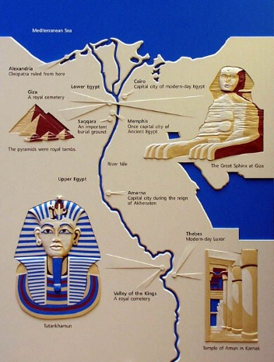
Key Concept Questions
Who were the Ancient Egyptians? When and where did they live?
Why was the Nile so important to people in the Ancient Egyptian times?
What is the Ancient Egyptian ritual of mummification?
What can we learn about the Egyptians from the discovery of Tutankhamun?
How is Egyptian writing different to our writing?
What different gods did they believe in?
How and why were the pyramids built?
What games did they play?
What was daily life like? (jobs/culture/food)
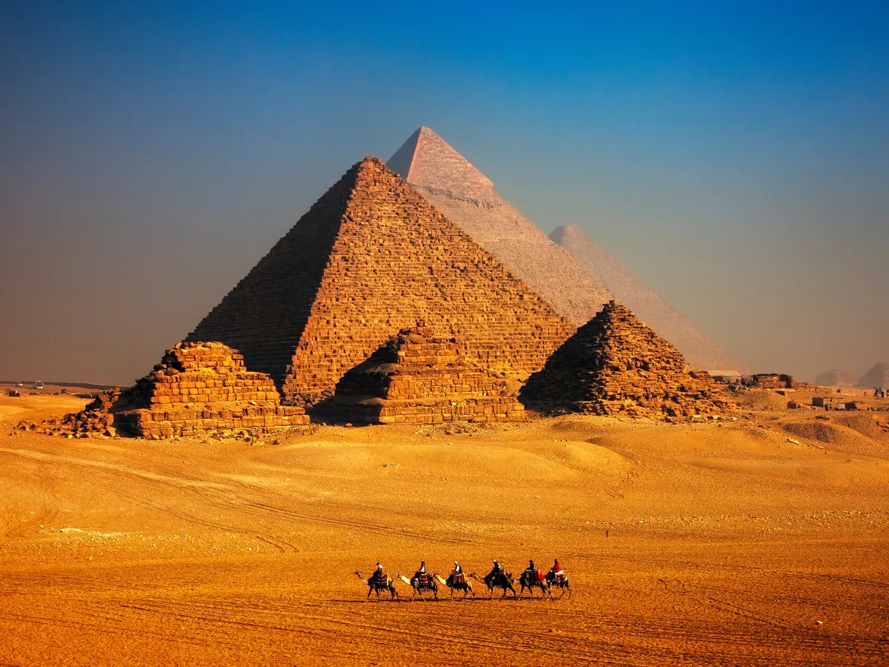

High Frequency Vocabulary (Tier 2)
Decade  BC and AD  pyramids | Century  Irrigation  Egyptian | Millennium  Pharaoh  afterlife

