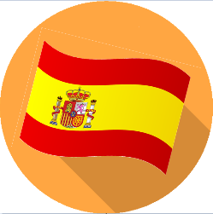
Unit 2 – Spanish KCV –Presenting Myself/ Phonetics 2 – Me Presento
Words to know and to spell (Tier 2 Vocabulary)
¿Cómo te llamas? | ¡Hola! | ¿Cómo estás?
Estoy bien | Estoy mal | Más o menos (or así, así)
¡Adiós! | once | doce
trece  dieciséis  diecinueve | catorce  diecisiete  veinte | quince  dieciocho
Key facts to learn:
- The pronunciation of the next 5 key phonemes/sound patterns: CA CE CI CO CU
- How to ask someone how they are feeling
- How to ask someone where they are from
- How to punctuate a question in written Spanish form
- How we show the person talking or being described is female (adjectival agreement)

Words to understand and begin to spell (Tier 3 Vocabulary)
¿Cuántos años tienes? | How old are you?
Tengo.. | I am… years old
¿Dónde vives? | Where do you live?
Vivo en.. | I live in ..
Soy español | I am Spanish (male)
Soy Española  Soy inglés  Soy inglesa | I am Spanish (female)  I am English (male)  I am English (female)
Unit 2 - Spanish – Autumn 1 – Heyford Park School
Concept check questions. Test yourself:
How is a question punctuated when written in Spanish?
What are the Spanish first person verbs for ‘I am’ ‘I have’ and ‘I live’?
How do you ask someone where they are from in Spanish?

Key skills to do:
- Count from 11-20 in Spanish
- Ask someone their name and give an appropriate reply when asked
- Ask others how they are feeling and give an appropriate reply when asked
- Ask someone where they are from and give an appropriate reply when asked
- Learn five of the key sound patterns/phonemes: CA CE CI CO CU to aid pronunciation.

