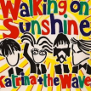
Year 6 Music KCV
Summer 2: Reflect, Rewind and Replay

Prior Learning
Children will know about singing, how their voices can sing sounds in various ways, creating various sounds.
Children will have a knowledge of tempo, pitch, rhythm and dynamics of a song and how these can change.
Children will have been exposed to songs from a variety different genres such as hip hop, Afropop, pop, rock, RnB and Latin.
Children will have had experience of improvising, composing, and performing.
Children will be able to recognise a variety of different instruments within a song.
Children will be able to gauge the emotion and feelings portrayed throughout a song and the ways in which this is done.
Children will have an understanding of jazz, swing and Bossa Nova music.

Key Learning
By the end of the term children will have gained the following knowledge and skills:
This Unit consolidates the learning that has occurred during the year. All the learning is focused around revisiting songs and musical activities, a context for the History of Music and the beginnings of the Language of Music.
Continue to embed the foundations of the interrelated dimensions of music using voices and instruments.
Tried a variety of different ways of making music.
Listen and Appraise Classical music
Compose a piece of music.

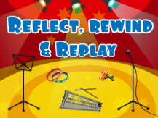
Key Concept Questions
What is your favourite style of music and why?
After composing a song/piece of music, what would you call it and why?
Can you compare two different styles of music?

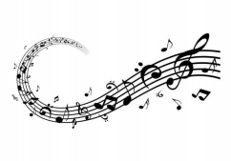
High Frequency Vocabulary
Song | Beat
Lyrics | Unison
Rhythm | Timbre
Pitch | Instruments
Pulse | Structure
Tempo | Texture
Bars | Melody
Dynamics | Compose
Hook | Improvise
Verse | Chorus
Introduction | Instrumental
Unison | Solo

Subject Specific Vocabulary
Classical  Music | Classical music refers to a very definite period in the history of music, which is called the classical period.
Stave | A set of five horizontal lines and four spaces that each represent a different musical pitch.
Clef | A musical symbol used to indicate the pitch of written notes.
Semibreve | Equal to four crotchets and takes up and entire measure in time.
Semibreve Rest | A pause or interval of silence equal in duration to two half rests or ne half of a breve rest.

