Tigers – PE – Target Games
Key Skills:
Physical:
- Underarm throwing, overarm throwing, aim, hand-eye coordination.

Social:
- Communication, supporting and encouraging others, leadership
Emotional:
- Honesty, perseverance, fair play

Thinking:
- Using tactics, selecting and applying skills, decision making

Words to know and spell (Tier 2 Vocabulary)
Far | Aim | Team
Throw | Score | Send
Points | Distance
Words to understand and spell (Tier 3 Vocabulary)
Target | The object that is being aimed for.
Agility | The ability to change direction quickly and easily.
Release | The point at which you let go of an object.
Co-ordination | The ability to move two or more body parts at the same time.
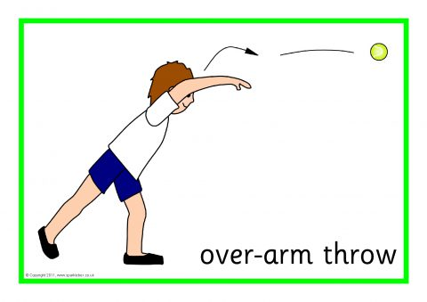
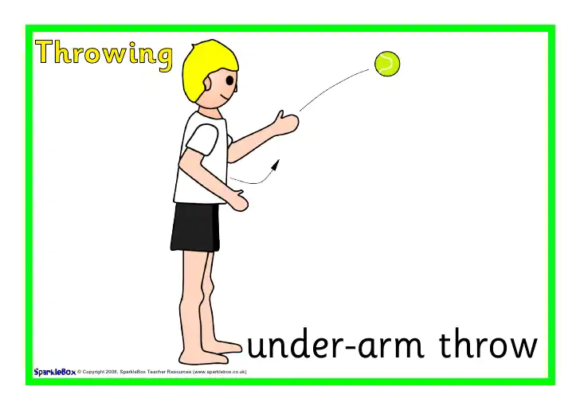
Key skills to do:
- Explore technique when throwing overarm towards a target.
- Explore technique when throwing underarm towards a target.
- Explore striking a ball with their hand and equipment.

Concept check questions. Test yourself:
What happens to my body when I exercise?
How can I accurately hit a target?
How can I work nicely with a partner?
What does good technique look like?

