Flamingos – PE – Ball Skills
Key Skills:
Physical:
- Rolling, kicking, throwing, catching, bouncing, dribbling.

Social:
- Communication, cooperation, leadership, supporting others
Emotional:
- Honesty, perseverance, challenging myself

Thinking:
- Using tactics, exploring actions.

Words to know and spell (Tier 2 Vocabulary)
Throw | Target | Roll
Catch | Underarm | Overarm
Collect | Distance | Dribble
Words to understand and spell (Tier 3 Vocabulary)
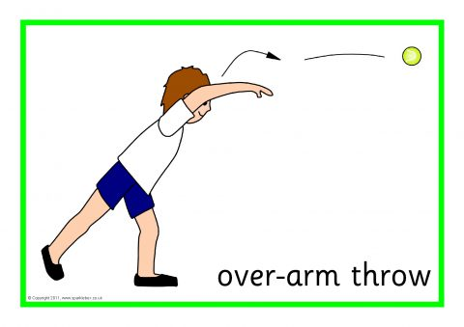
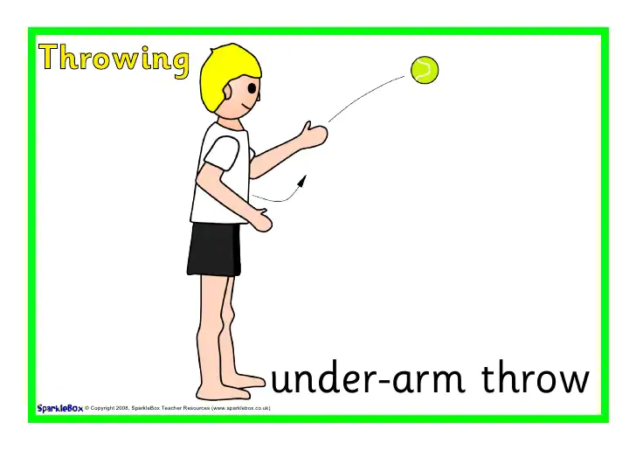

Key skills to do:
- Roll, throw and kick a ball to hit a target.
- Develop catching a range of objects with two hands.
- Catch with and without a bounce.
- Consistently track and collect a ball being sent directly.
- Dribble a ball with hands and feet with some control.

Concept check questions. Test yourself:
What is the best way to try and hit a target?
How do I dribble a ball with my hands?
How do I communicate well with my partner?
How do you show good sportsmanship?
What happens to my body when I exercise?

