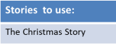
Freeland CE Primary School
KCV Mat for RE – Kingfishers Autumn 2
Theme: Christmas Religion: Christianity
