Year 1 – RE KCV – Creation
Key facts to learn:
• That the creation story is the first book in the bible and that it is called Genesis.
• Adam was the first man and Eve was the first woman that God made.
• God made the world in seven days.
• God wanted people to look after the world He created.
Words to know and spell (Tier 2 Vocabulary)
create | space | believe
world | care | people
nature | proud | damage
Words to understand and spell (Tier 3 Vocabulary)
Creation | When something is made. Christians believe that God created the world.
Christians | A member of a Christian church who believes in God.
God | A being that is worshipped as the maker of the world.
Genesis | The first book of the bible.
Adam and Eve | The first man and woman made by God.
Trust | To believe in something or someone.
Precious | Great worth or importance.
Environment | The things that surround animals and humans in the natural world.
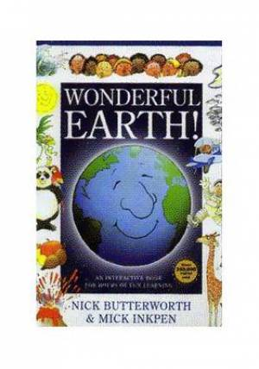
Key skills to do:
• Explore and retell the Christian creation story.
• Express an opinion about creation.
• Discuss how the world got here.
• Use creative ways to express their own ideas about the creation story.
Text to use:
Wonderful Earth by Nick Butterworth and Mick Inkpen

Concept check questions. Test yourself:
Does God want Christians to look after the world?
How do I wat my creations to be treated?
Why did God create the world?
Year 1 – RE – Autumn 1 – Heyford Park School

