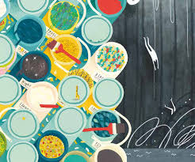
KS2 RE KCV –Maple Class Autumn 2 2023
Big Question: What do Christians learn from the Creation story?

Big Question: What do Christians learn the the Creation story?
a) How do people’s beliefs about and attitudes towards God, the universe and humanity act as a guide through life?
e) How are religious and spiritual ideas expressed and why is literal language not adequate?
g) How should people’s religious and other beliefs, values and attitudes influence their personal lives and is it possible to live up to this?
Hindu/Art/Symbol/ God

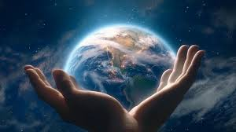
High Frequency Vocabulary (Tier 2)
God  Image  Christianity | Forgiveness  Creator  Christian | Awe and wonder  Design  World

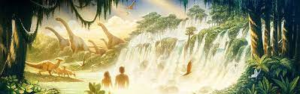
Subject Specific Vocabulary (Tier 3)
Creation  Sin  Genesis  Temptation  The Fall  Image | The action or process of bringing something into existence.  To disobey  The first book of the Bible  The desire to do something wrong  Adam and Eve fell away from God  A picture or likeness

Key Questions:
What do Christians believe about the creation of the world?
What does Genesis 1 teach Christians about God and the importance of the world?
What do Christians believe about the Bible?
Why should we look after the world?
What do Christians believe about humans?

