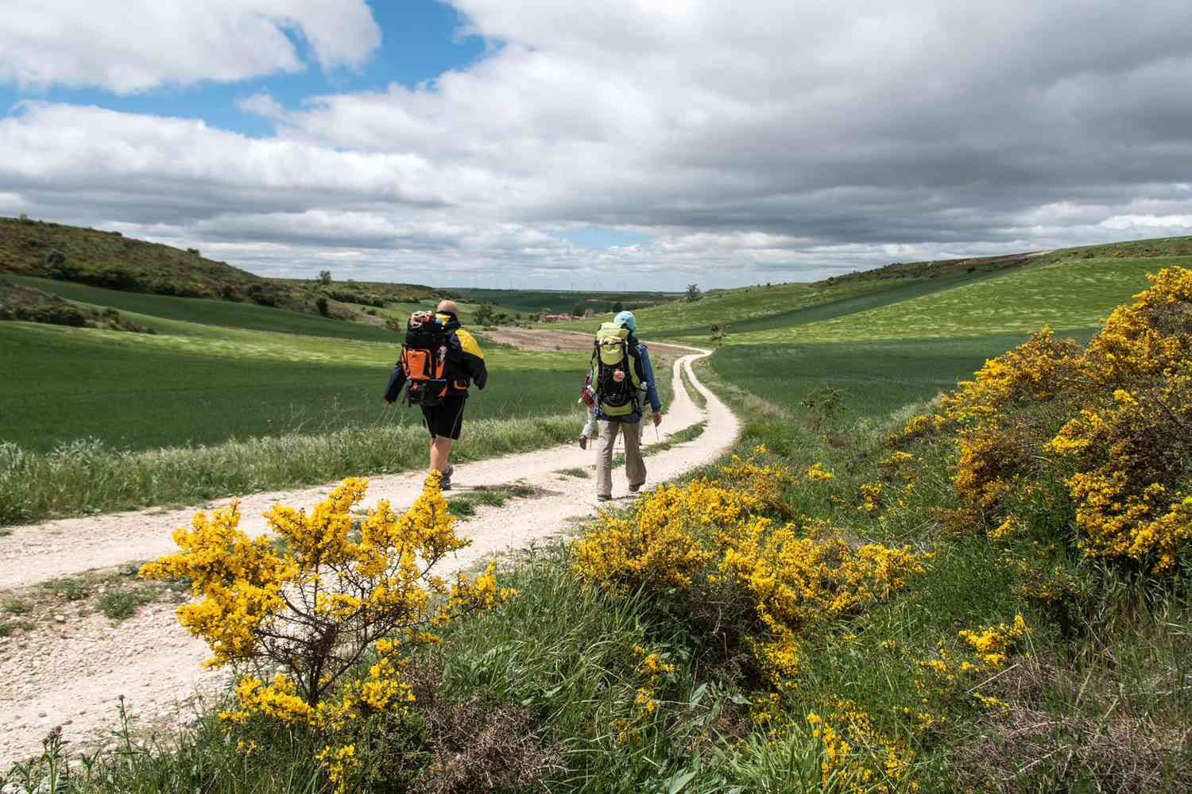
KS2 RE KCV –Maple Class Spring 1 2024
Big Question: Is a holy journey necessary for believers?
?

Big Question: What do Christians learn the the Creation story?
a) How do people’s beliefs about and attitudes towards God, the universe and humanity act as a guide through life?
e) How are religious and spiritual ideas expressed and why is literal language not adequate?
g) How should people’s religious and other beliefs, values and attitudes influence their personal lives and is it possible to live up to this?
Hindu/Art/Symbol/ God

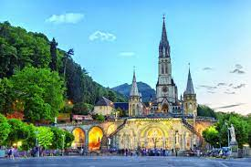
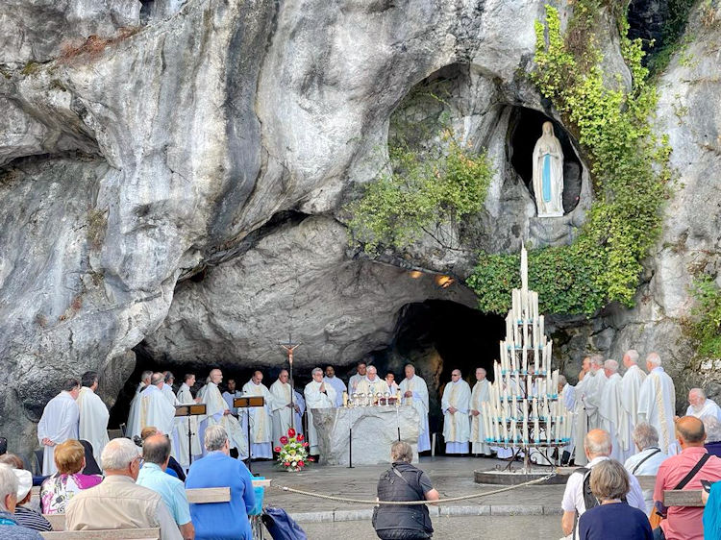

High Frequency Vocabulary (Tier 2)
Hindu  Hinduism  Christianity | Journey  Christian  Faith | Importance

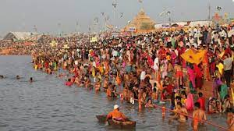
Subject Specific Vocabulary (Tier 3)
Pilgrimage  Sacred | A special journey to a place that is important for religious reasons.  Something that is connected with God or a god.
Miracle  Holy | Something extraordinary and positive that is believed to happen because of another power, such as a god.  Something or somewhere that is dedicated to or associated with God or a religious purpose.

Key Questions:
- What is a pilgrimage? Why do people go on a pilgrimage?
- What Christian places of pilgrimage are there?
- What Hindu places of pilgrimage are there?
- What similarities /differences are there between places of pilgrimage?

?

