KS2 Science KCV – Sound
Key Knowledge | Detail
identify how sounds are made, associating some of them with something vibrating.  recognise that vibrations from sounds travel through a medium to the ear.  find patterns between the pitch of a sound and features of the object that produced it.  find patterns between the volume of a sound and the strength of the vibrations that produced it. | Observe different instruments to identify the sound source  Test different mediums to determine efficiency of sound travel.  Use data to determine the length of a vibrating object and the pitch it produces.  Use data to determine the size of a sound wave and the volume it produces.  Test the distance that sound can travel.
recognise that sounds get fainter as the distance from the sound source increases.
Key skills
- ask relevant questions and use different types of scientific enquiries to answer them.
- set up simple practical enquiries, comparative and fair tests.
- make systematic and careful observations and, where appropriate, take accurate
measurements using standard units, using data loggers.
- gather, record, classify and present data in a variety of ways to help in answering
questions.
- record findings using simple scientific language, drawings, labelled diagrams, keys,
bar charts and tables.
- use results to draw simple conclusions, make predictions for new values, suggest improvements and raise further questions.

Parts of the ear and other vocabulary
Amplitude  Cochlea  Decibel  Ear Canal  Ear Drum  Hair Cells  Ossicles | A measure of the strength of a sound wave.  A twisted tube inside the inner ear that is the main organ of hearing.  A measure of how loud a sound is.  A pathway running from the outer ear to the middle ear.  A thin, cone-shaped membrane that separates the external ear from the middle ear.  Hair cells are the sensory receptors in the inner ear that detect sound.  The three smallest bones in the human body. They may be called ear bones or auditory ossicles.

High Frequency Vocabulary
Energy | Power | Travel | Pitch
Frequency  Ear | Sound Waves | Vibrations  Hear | Air
Medium | Source | Volume | Solid

Key concept questions
How are sounds made?
How do we hear sounds? How do sounds travel? How do sounds change? How can you measure sounds?

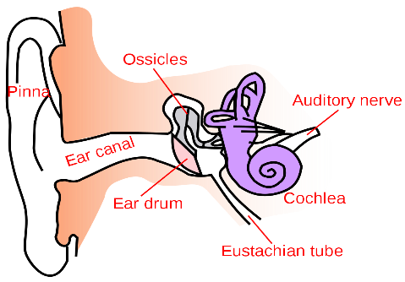
This Photo by Unknown Author is licensed under CC BY-SA

