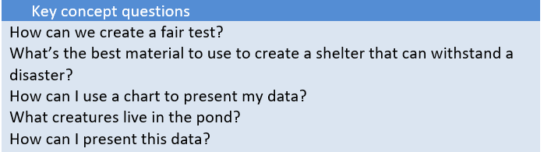
KS2 Science KCV – Working Scientifically
Key Knowledge | Detail
Asking relevant questions and answering them.  Setting up practical enquiries and fair tests.  Gathering results, recording them and presenting them.  Exploring different ways of representing data. | Creating their own questions and using different types of scientific enquiries to answer them.  Setting up simple practical investigations, comparative and fair tests.  Gathering, recording, classifying and presenting data in a variety of ways to help in answering questions.  Recording findings using simple scientific language, drawings, labelled diagrams, keys, bar charts and tables.
High Frequency Vocabulary
Enquiries, Materials, Practical, Comparative, Durability, Strength, Test, Recording, Questioning, Measuring, Timing, Observing.
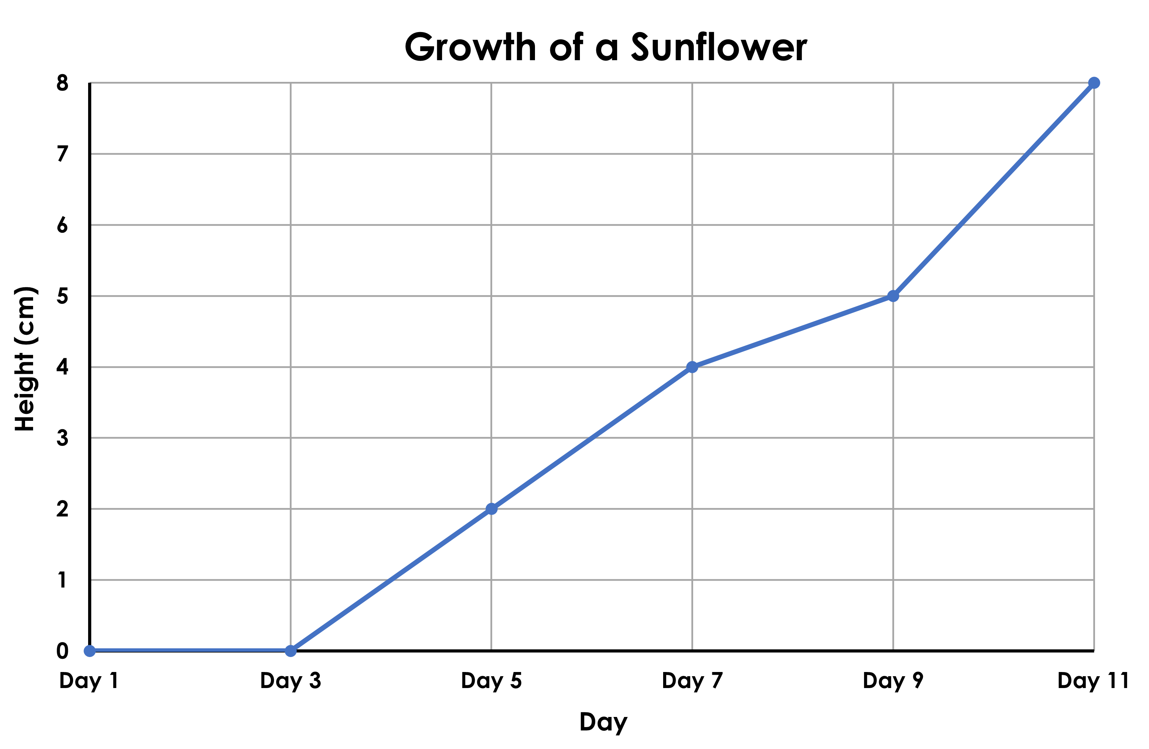
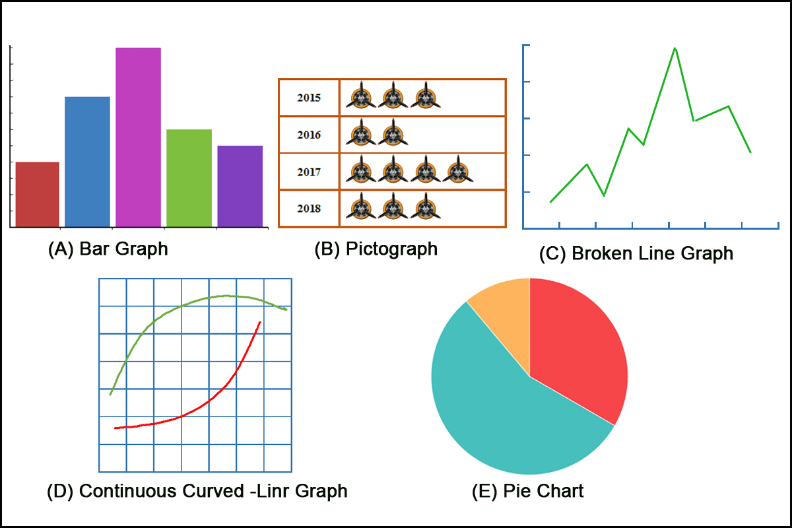
Key Vocabulary
Fair  Results  Investigation  Graphs  Predictions | Not favouring one thing over another.  Something that comes about as an effect or end to an experiment or investigation.  To study something by close examination or questioning.  A pictorial representation or diagram that represents data or results in an organised way.  Making an informed guess of what you think will happen.

