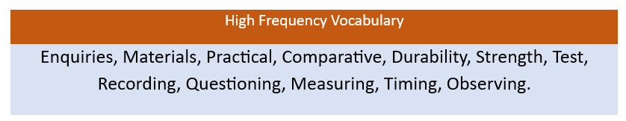
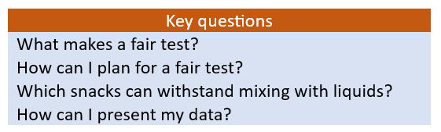
KS2 Science – Working Scientifically testing reactions
Key Knowledge | Detail
Asking relevant questions and using scientific enquiries to answer them.  Setting up practical enquiries and fair tests.  Making careful observations and taking accurate measurements using equipment.  Exploring different ways of representing data. | Creating their own questions and using a fair test/enquiry to answer them.  Setting up simple practical investigations, comparative and fair tests.  Gathering, recording, classifying and presenting data in a variety of ways to help in answering questions.  Recording findings using scientific language, drawings, labelled diagrams, keys, bar charts and tables.
Key Vocabulary
Enquiry  Measurement  Tables  Pictograms  Line graph | Conducting an investigation.  To find the amount of something using a piece of equipment  A set of facts or figures presented systematically.  A table of results using pictures to represent facts/figures.  A graph that uses lines to connect data points.
