KS2 Science KCV – Forces and magnets
Key Knowledge | Detail
compare how things move on different surfaces | Study push and pull actions  Consider friction and impact on movement
notice that some forces need contact between two objects, but magnetic forces can act at a distance | Understand that magnets can move metallic objects without direct contact
observe how magnets attract or repel each other and attract some materials and not others | Know that magnets have two poles which create attraction and repulsion.  Know which materials are attracted to magnets.
Set up simple practical enquiries, comparative and fair tests | Investigate the movement of a object over different surfaces

Vocabulary
Push | An action that moves an object away from the force
Pull | An action that moves an object towards the force
Friction | Amount of resistance between an object and a surface
Surface | Material an object is resting on
Force | Power exerted on an object
Newtons | Unit of force
Magnet | Magnetised metal
North pole | One end of a bar magnet
South pole | One end of a bar magnet
Attract | Where an object moves towards a magnet
Repel | Where an object moves away from a magnet

Key concept questions
When is a force a push or a pull?
What is friction?
How does friction affect movement?
Which materials respond to a magnet?
How do the poles on two magnets interact?

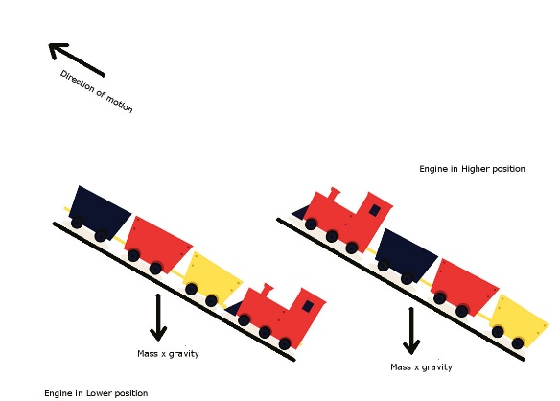
This Photo by Unknown Author is licensed under CC BY-SA
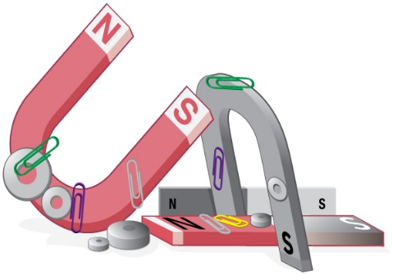
This Photo by Unknown Author is licensed under CC BY

