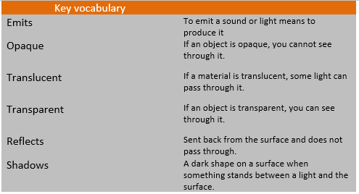
KS2 Science KCV – Light
Key Knowledge | Detail
- recognise that they need light in order to see things and that dark is the absence of light  - notice that light is reflected from surfaces  - recognise that light from the sun can be dangerous and that there are ways to protect their eyes  - recognise that shadows are formed when the light from a light source is blocked by a solid object  - find patterns in the way that the size of shadows change. | Explore the levels of light needed to see details.  Investigate surfaces that reflect or absorb light  Consider the impact and dangers of looking at bright lights.  Explore the materials that make shadows.  Explore the factors that alter shadow size and position.
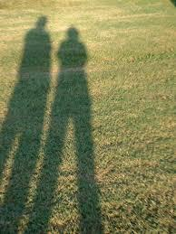
Key concept questions
What is light and dark?
How do we see in the dark?
How do we use light sources safely?
Why do we see a reflection in a mirror?
What makes a shadow?
How and why do shadows change?
