KS2 Science KCV – Rocks
Key Knowledge | Detail
- compare and group together different kinds of rocks on the basis of their appearance and simple physical propertie.  - describe in simple terms how fossils are formed when things that have lived are trapped within rock  - recognise that soils are made from rocks and organic matter. | ∙ There are three types of rocks that are formed naturally.  ∙ Igneous  ∙ Sedimentary  ∙ Metamorphic  ∙ Fossils are the remains of prehistoric life. ∙ They are usually formed when a living thing (plant or animal) dies and the body is covered up or buried by sediment over tens of thousands of years.  ∙ Soil is made from pieces of rock, minerals, decaying plants and water.
Key concept questions
What are the different types of rock?
How can we group types of rocks?
How are fossils formed?
How are soils different?

High Frequency Vocabulary
absorb bedrock  decaying  grain  igneous  leaf litter magma  metamorphic rocks  molten  nutrients  palaeontology  permeable  porous  prehistoric  preserve pressure  properties  rock  sediment  soil  surface  volcano  weathered | soak up or take in  the solid rock in the ground which supports all the soil above it  gradually being destroyed by a natural process  A grain of something such as sand or salt is a tiny hard piece of it  rocks that are formed by volcanic action or intense heat imprint  decaying leaves  molten rock that is formed in very hot conditions inside the earth  that have had their original structure changed by pressure and heat mineral something that is formed naturally in rocks and in the earth. Molten rock, metal, or glass has been heated to a very high temperature and has become a hot, thick liquid  substances that help plants and animals to grow the study of fossils as a guide to the history of life on Earth  if a substance is permeable, something such as water or gas can pass through it or soak into it. Something that is porous has many small holes in it, which water and air can pass through  the time in history before any information was written down  to protect from decay  force that you produce when you press hard on something  the qualities or features that belong to something and make it recognisable  a solid mass made up of minerals.  solid material that settles at the bottom of a liquid  the substance on the surface of the earth in which plants grow  the flat top part of something or the outside of it a mountain from which hot melted rock, gas, steam, and ash from inside the Earth sometimes burst.  affected by the weather
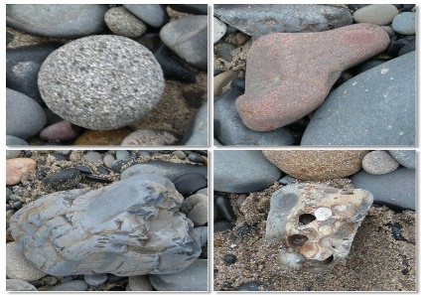

This Photo by Unknown Author is licensed under CC BY
Key Vocabulary
Igneous
Metamorphic
Sedimentary
Fossils
Soil

