Key Vocabulary
Solid | A material that keeps its shape
Liquid | A material that flows to fill space from the lowest point
Gas | A material that flows to fill all available space
Melting | When heat is applied to a solid the particles vibrate more, reducing the forces holding them together. This causes them to move apart, breaking the solid structure and becoming a liquid.
Condensation | When a gas has heat removed from it the particles in the vapour slow down, come together and loosely bond, returning to the liquid state
Evaporation | When heat is applied to a liquid the particles move around even faster, breaking away from each other and forming a gas or vapour. When this happens to all the particles it is called boiling
Solidifying | This is when cooling of a liquid slows the movement of the particles and they become solid at or near room temperature
Freezing | As above, but it happens at cold temperatures.
Temperature | A measure of the heat in an object or space
Steam | Steam is the name given to the gaseous state of water at or above 100 degrees Celsius and is not visible
Vapour | Water vapour is the gaseous state of water below 1oo degrees Celsius and is visible as tiny water droplets
Water cycle | The water cycle depends upon the processes of evaporation, condensation and precipitation. Precipitation is water falling from the air as rain, snow, sleet or hail. Evaporation occurs on the oceans, land, lakes and rivers. Some of the cooled water vapour condenses on small particles of dust or soot present in the atmosphere and clouds containing water droplets or ice are formed. The water droplets need to reach a certain size before they begin to fall.
KS2 Science KCV – States of matter
Key Knowledge | Detail
- compare and group materials together, according to whether they are solids, liquids or gases | Identify common solids, liquids and gases.  Be able to group materials according to their state.
- observe that some materials change state when they are heated or cooled, and measure or research the temperature at which this happens in degrees Celsius (°C) | Investigate changes of materials when exposed to heat or cold
- identify the part played by evaporation and condensation in the water cycle and associate the rate of evaporation with temperature. | Understand the process of the water cycle and how the states of water are involved.
Key concept questions
What is a solid or a liquid or a gas?
How do states change?
Why do some solids appear to be liquids?
How does water move around the Earth?

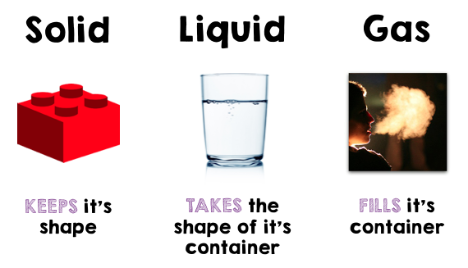
This Photo by Unknown Author is licensed under CC BY-SA-NC

