KS2 Science KCV – Electricity
Key Knowledge | Detail
- identify common appliances that run on electricity | Look at examples of where different sources of electricity are used.
- construct a simple series electrical circuit, identifying and naming its basic parts, including cells, wires, bulbs, switches and buzzers | Use circuit components to power a range of devices, including motors for a mini buggy.
- identify whether or not a lamp will light in a simple series circuit, based on whether or not the lamp is part of a complete loop with a battery | Solve problems when a device does not work. Where is the circuit broken?
- recognise that a switch opens and closes a circuit and associate this with whether or not a lamp lights in a simple series circuit | Make a circuit that includes a switch to start and stop a powered buggy.
- recognise some common conductors and insulators, and associate metals with being good conductors. | Investigate the best materials to use in their own switched circuit for a control device for a powered buggy.
Key skills
- Make systematic and careful observations and, where appropriate, take
accurate measurements using standard units, using a range of equipment, including thermometers and data loggers
- Gather, record, classify and present data in a variety of ways to help in answering questions
- Record findings using simple scientific language, drawings, labelled diagrams, keys, bar charts, and tables
- Identify differences, similarities or changes related to simple scientific ideas and processes
- Use straightforward scientific evidence to answer questions or to support his/her findings

vocabulary
Conductor | Allows electrical energy to flow through
Insulator | Prevents electrical energy from flowing through
Circuit | A sequence of connected components joined without a break.
Current | Measure of electrical energy flow

High Frequency Vocabulary
electricity, circuit, switch, battery, plug, mains, appliance, device, wire, crocodile clip, bulb, buzzer, connection, power, cell, conductor, insulator, energy, flow, current, motor

Key concept questions
Where does electricity come from?
How do electrical devices work?
What is an electrical circuit?
What makes electricity turn on and off?
What materials are good conductors?
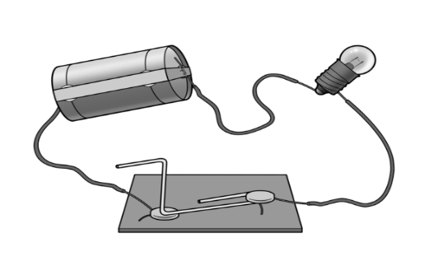
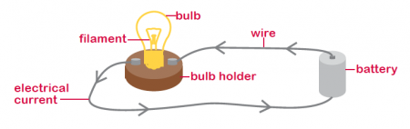
This Photo by Unknown Author is licensed under CC BY-ND

