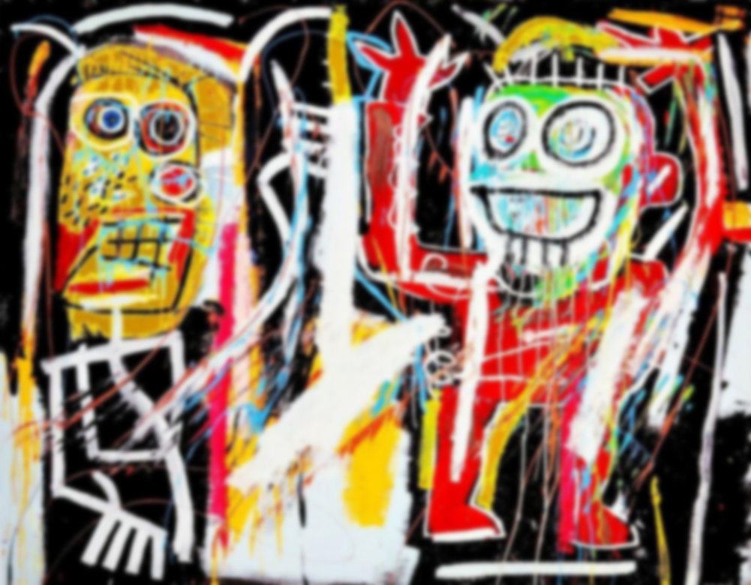

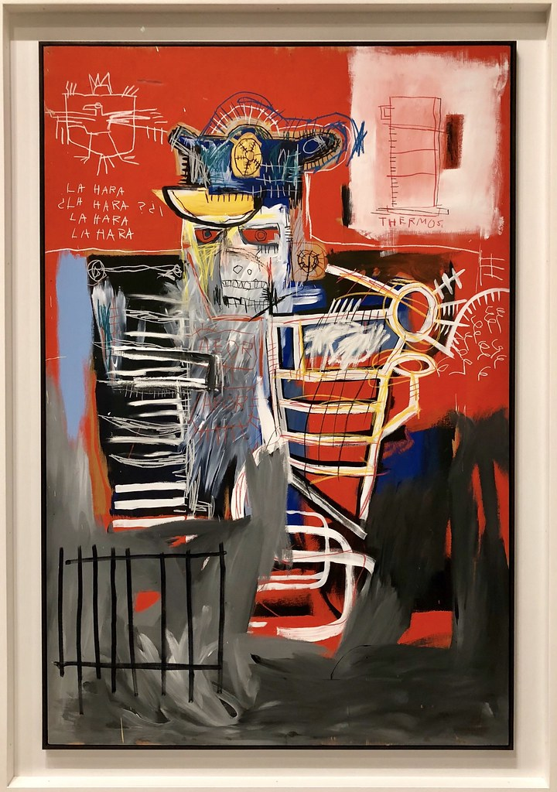

**Vocabulary**

**Crosshatching:** crossed lines for shading.

**Emotive:** create intense feeling

**Conceptual:** artwork based around an idea.

**Gradient:** a gradual fading of tone or colour.

**Evaluate:** criticise the good and bad parts of a piece of work.

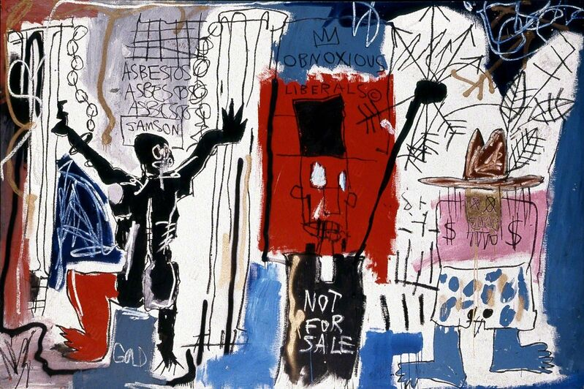

**Learning point 3: Sketching figures and movement**

I can use sketching to inform a drawing.

* Use photographs of people (athletes) in motion.
* Sketch to indicate proportion – soft, quick lines.
* Use soft dark pencils to add in some detail and pattern. Use drawings of skeletons and anatomical studies to help.

***Look at ‘Warrior’ and create a sketch of a human figure in action. The lines should combine soft and heavy strokes.***

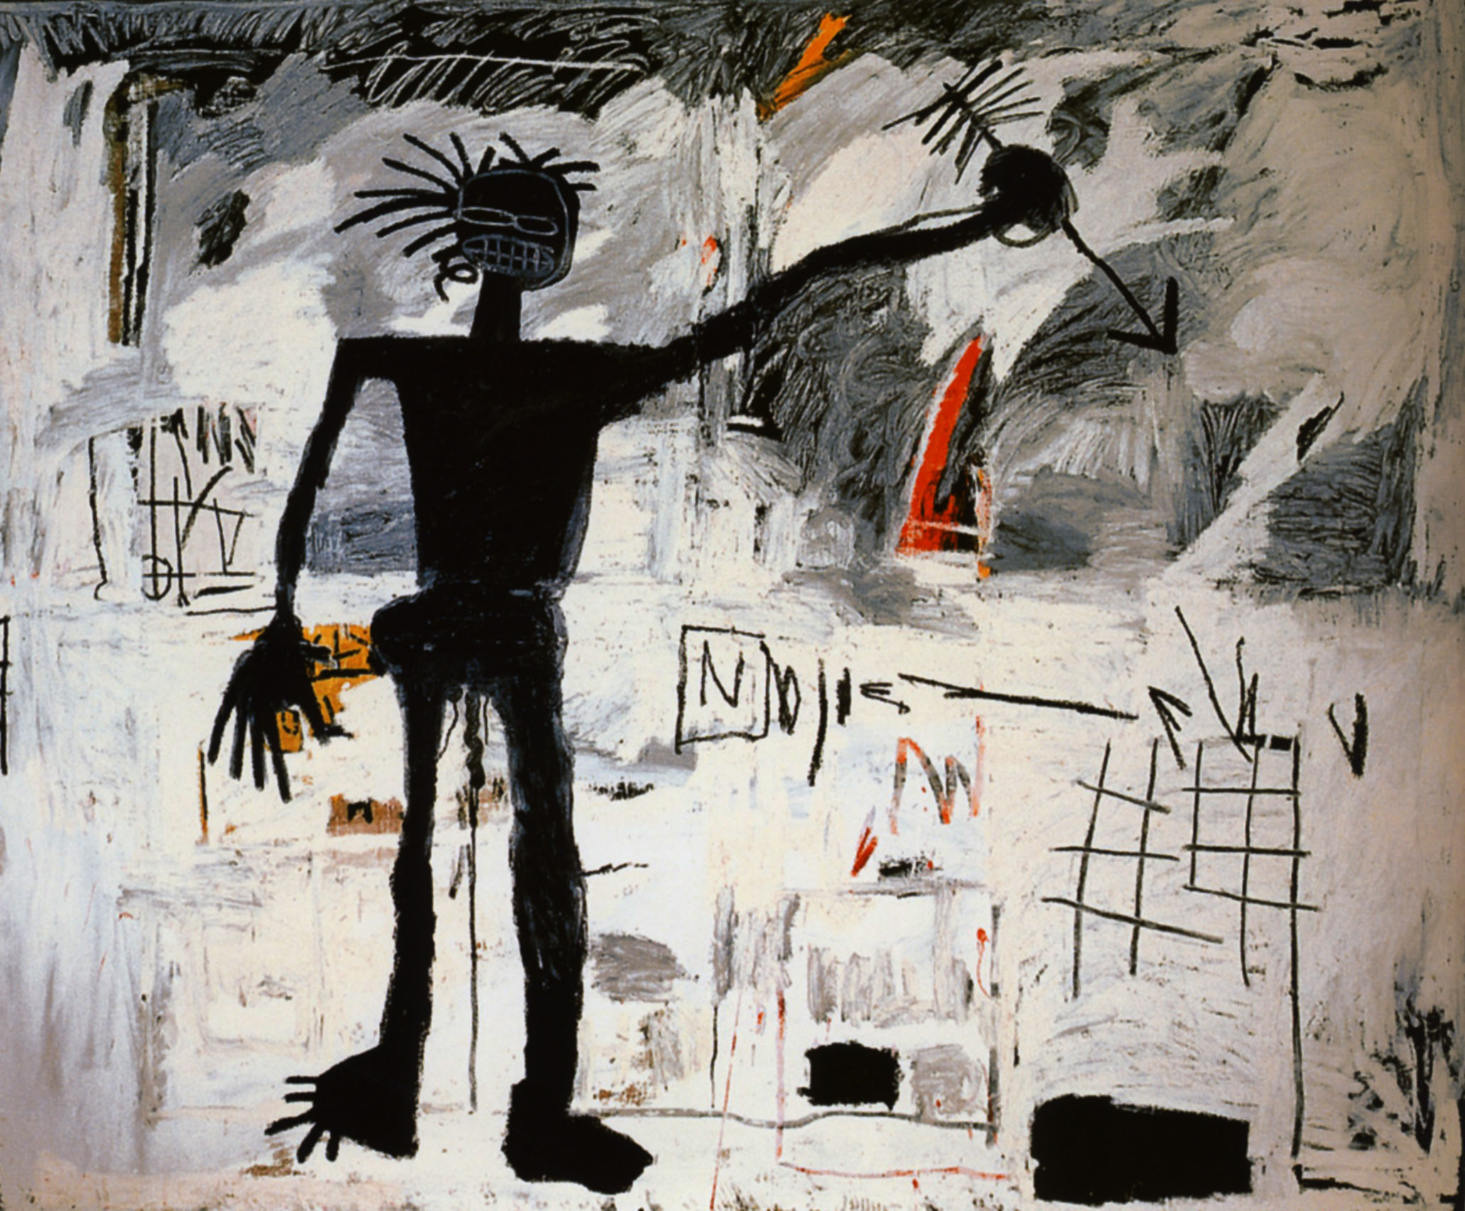

**Learning point 2: Creating shading**

I can use pencils and lines to create shading.

* Use different grades of pencils to create a shading gradient.
* Use cross-hatching and dashes to create darker areas.
* Use an eraser to create lighter areas within shading.

***Look at ‘Self Portrait 1982’ and create a shading gradient. Use crosshatching, line, and an eraser to add a figure shape on top of the gradient. Use text if possible.***

**Previous Knowledge**

* Knowledge of sketching to plan a piece of work.
* Pencils can be hard and light or soft and dark.
* Sketchbooks are used to record ideas.
* Critiquing artwork can help to improve future pieces.

**Final Piece: Create a piece of artwork, inspired by Oxford and ‘Untitled Skull 1982.’**

I can create artwork in the style of Jean-Michel Basquiat.

* Look at several of Basquiat’s pieces, including ‘LA Hara’, and discuss the themes and meaning behind the paintings.
* Discuss lines and depth of shading to show emotions.
* Discuss the above in relation to ‘Untitled Skull 1982’.
* Create a collage background using torn paper. Take a self-portrait photograph, showing an exaggerated emotion.
* Draw a portrait, using dramatic lines to show anger, fear or anxiety.
* ***Evaluate your work. How is it similar/different to Basquiat’s? Do you like this style? Why?***

**Learning point 4: Communicating ideas**

I can explain how my drawing reflects my feelings on a subject matter.

* Look at Obnoxious Liberals and discuss the political meaning, linking to slavery and control of power.
* Notice how the jagged lines and faces show anger and disdain. Discuss a contrasting piece by another artist. Compare the two.
* Discuss how you could show pity, anger, empathy and other emotions in a drawing.

***Use photos of poverty or another emotive subject based on Oxford. Use shading and line to convey your feeling towards this.***

**Jean-Michel Basquiat**

**Untitled Skull 1982**

**Learning point 1: Artist research**

I can find out about a well-known artist.

* Look closely at some of the works of Jean-Michel Basquiat.
* Discuss his life and what inspired him to start creating artwork.
* Discuss how his artwork makes you feel.
* Record some of this information in a sketchbook with annotations.

***What themes did Basquiat address in his work? What pieces did he create?***