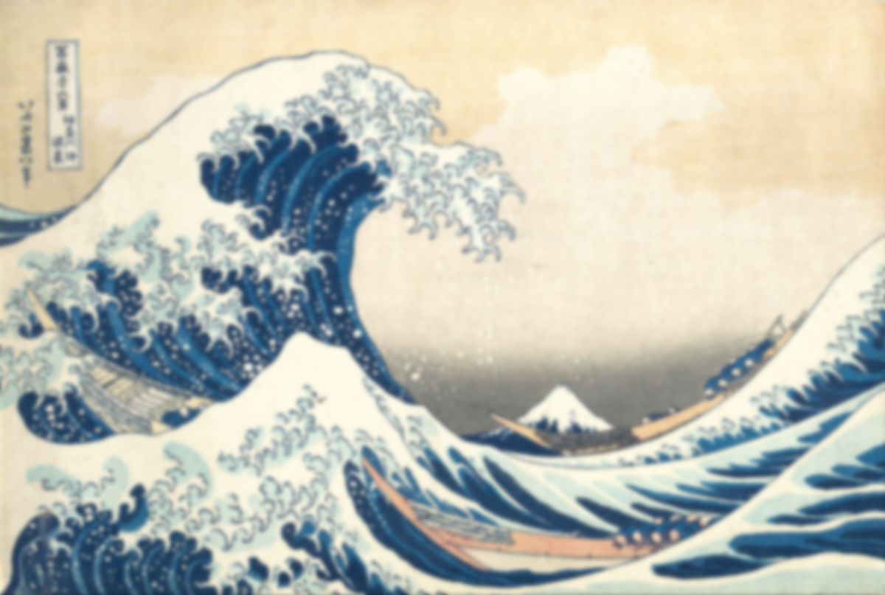

**Learning point 2: Creating gradients.**

I can use colour washes to create gradients.

* Look at the background colours of several of Hokusai’s works: identify the colour gradient.
* Discuss how it gives an ephemeral quality.
* Demonstrate using more water than paint to create a blend of colour which fades seamlessly into another.
* Refer to the colour wheel for effective colour combinations.

***Look at ‘Yoro Waterfall in Mino Province’ and other works and create a colour gradient using watercolour washes.***

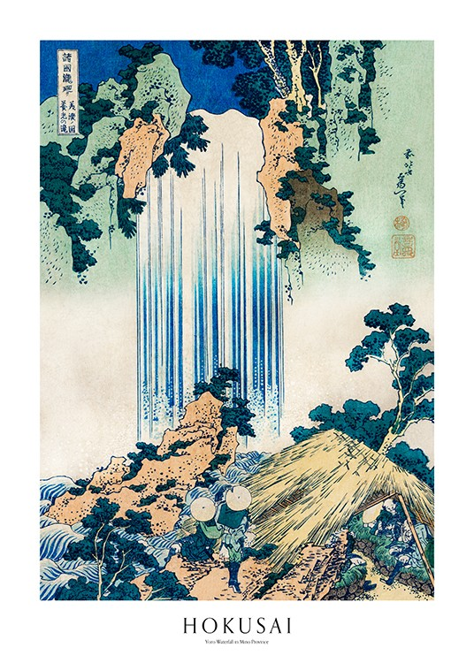

**Previous Knowledge**

* Knowledge of painting and printing techniques
* Paints, including watercolours can be used for washes and detail.
* Sketchbooks are used to record ideas.
* Art has distinct periods and styles.

**Vocabulary**

**Ukiyo-e:** traditional Japanese art that involves woodblock printing

**Edo Period:** a period of Japanese history (1603-1868)

**Composition:** the way artwork has been arranged.

**Ephemeral:** art that captures a fleeting or transient moment

**Evaluate:** criticise the good and bad parts of a piece of work.

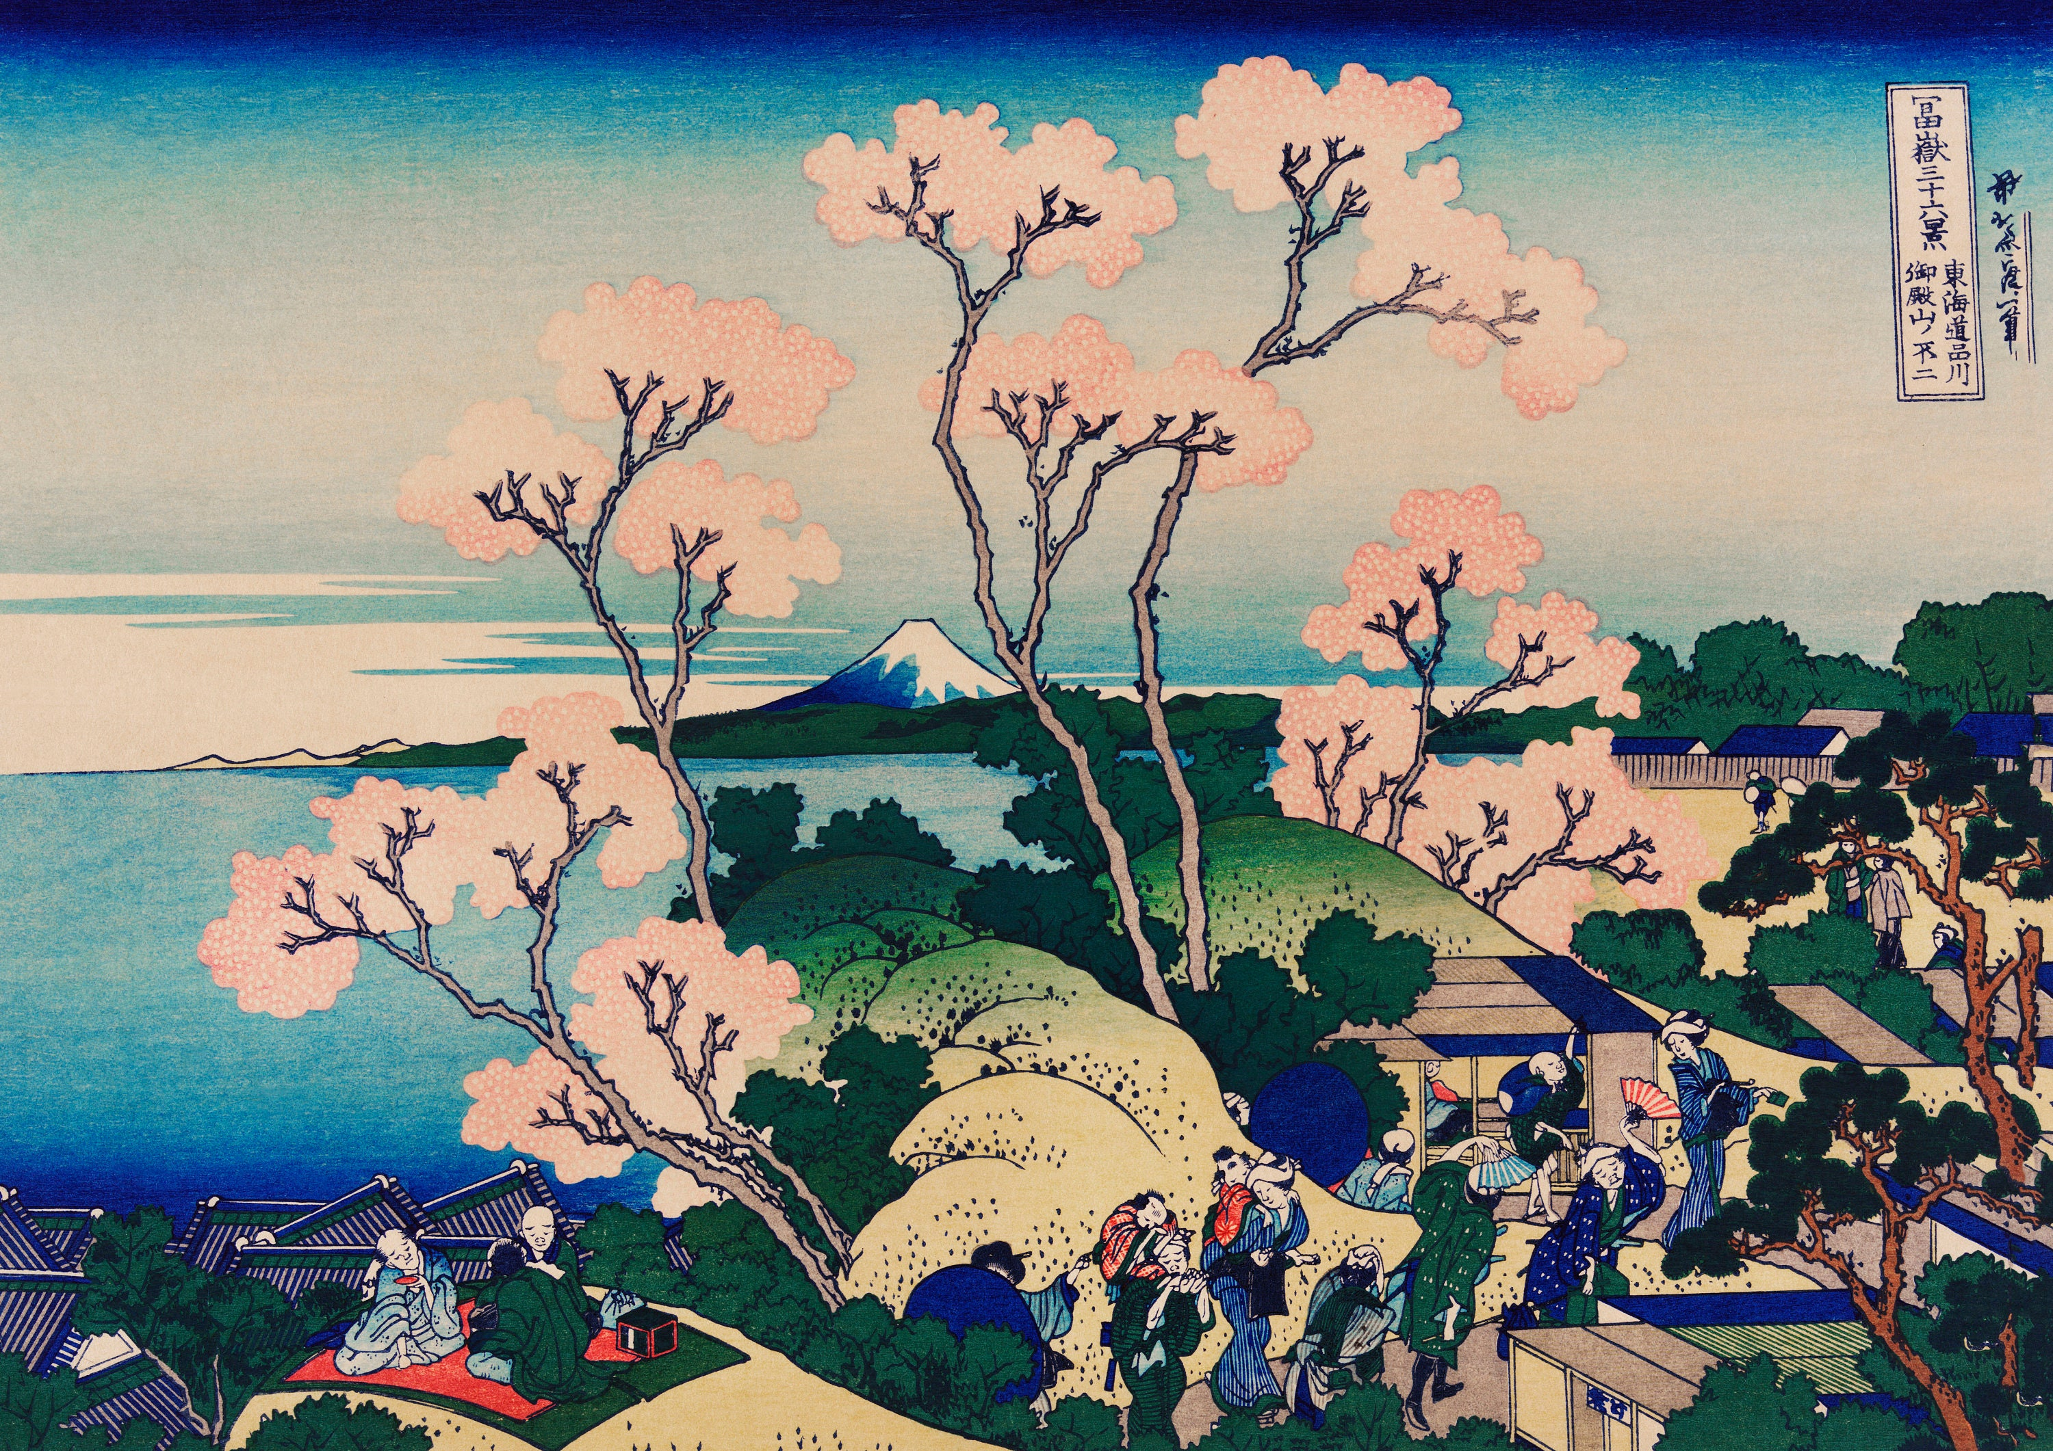

**Final Piece: Create a piece of artwork, inspired by the work of Hokusai.**

I can create artwork in the style of Hokusai.

* Review Hokusai’s work and note the serene, natural themes within it. Discuss composition.
* Discuss how it makes you feel and why.
* Review his most well-known piece of work ‘The Great Wave’ and remind children of the printing techniques used to make it.
* Use a combination of gradient colour washes, a monoprint element and then detailed brushstrokes to create a final piece.
* ***Evaluate your work. What elements do you like best? How could you improve the final piece? What benefits are there to printing over painting?***

**Learning point 4: Monoprint and detail**

I can create a monoprint and add detail.

* Discuss how Hokusai makes his works using a printing technique.
* Refresh using a monoprint with polystyrene to create a simple design.
* Demonstrate how to print and then paint areas on top with water colour for more detail.

***Make a monoprint tile and produce a print. This can then be developed by adding watercolour paint on top and adding detail around it.***

**Learning point 3: Painting techniques**

I can use different brush strokes and techniques for effect.

* Look at the way the trees have been created in ‘Red Fuji’ and waves in ‘Tama River in Musashi Province’, and discuss how detail can be created with simple dots and lines.
* Demonstrate using a simple horizon line and lines and dashes on top of a gradient to create the impression of trees.

***Make a swatch of lines and dots, then create a simple landscape using gradients, dashes, dots and lines. Add detail in desired.***

**Learning point 1: Artist research**

I can find out about a well-known artist.

* Look closely at some of the works of Katsushika Hokusai.
* Discuss his life and what inspired him to start creating artwork. Discuss Ukiyo-e style.
* Discuss the main subject of his work – why did he make work with a similar subject matter?
* Record some of this information in a sketchbook with annotations.

***What are the main stylistic features of Hokusai’s work? What inspired him?***

**Hokusai**

**The Great Wave off Kanagawa**

