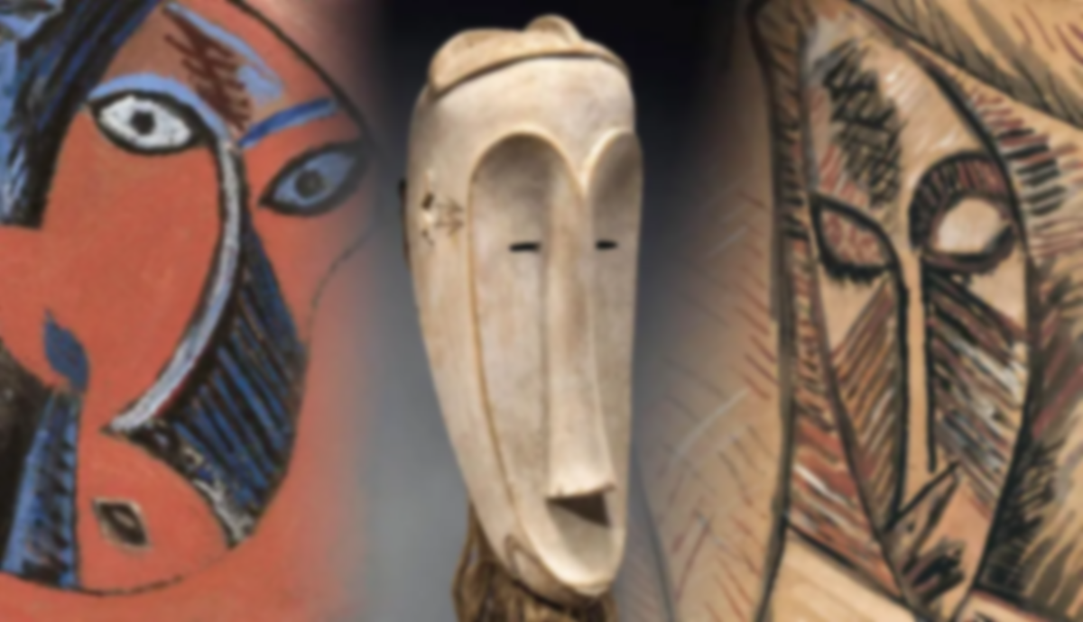

**Vocabulary**

**Sculpture:** 3 dimensional artwork.

**Modelling:** Adding clay to a clay surface.

**Carving:** Removing clay from a clay surface.

**Texture:** the feel of an object

**3 dimensional:** a shape with height, width and depth.

**Critique:** analysing in detail

**Pablo Picasso**

**Head of a Woman 1907**

**Learning point 3: Layered 3D portraits**

I can create a 3D relief self-portrait inspired by Picasso.

* Look at Picasso’s Self Portrait and discuss similarities and differences with the previous portrait.
* Discuss the tone and how we are going to move into 3D media – discuss sculptors and the work they make.

***Use card/cardboard to make a 3D relief portrait, inspired by Picasso’s self-portrait.***

**Final Piece: Self-Portrait in the style of Picasso.**

I can create a 3D portrait inspired by Picasso.

* Look back at Picasso’s work inspired by African masks. Discuss similarities and how they have influenced Picasso, rather than him imply copying.
* Discuss the textures you can see in both Picasso’s work and the African masks and remind children how this can be achieved.
* Look at the self-portrait from learning point 3’s session and create a version in clay, using tools to carve and model where necessary.

***Create a 3D self-portrait using clay. Critique the work. How is it similar/different to Van Gogh’s? Do you like this style? Why?***

**Learning point 4: Using clay for sculpture**

I can create texture and depth using clay.

* Children are given a piece of clay and tools and practice carving (removing) and modelling (adding) onto their piece of clay.
* Children create a simple tile by rolling out a small piece of clay.
* Look at a variety of African masks and make a simple mask, about 20cm x 20cm using a variety of carving and modelling techniques.

***Create a 3D African mask using clay. Use a variety of carving and modelling techniques.***

**Learning point 2: Portraits**

I can create a portrait using shape, line and colour.

* Discuss portraiture and look at some of Picasso’s portraits, which show distorted faces.
* Discuss the use of shape and colour and how it creates a bold, unusual looking face.
* Discuss cutting out shapes and placing them before drawing on top to make a portrait.

***Use bright paper cuts and paint to create a simple portrait, which emphasises colour, line and shape.***

**Learning point 1: Artist research**

I can find out about a famous artist.

* Look closely at some of the works of Picasso and some traditional African masks.
* Discuss similarities between them.
* Note down some key facts about Picasso.
* Record in sketch books how the African masks inspired Picasso, and which parts look similar.

***How have traditional African masks inspired the work of Picasso?***

**Previous Knowledge**

* Mark making on 2D surfaces.
* The use of line and shape to make recognisable pictures.
* Modelling with playdough and other malleable materials.

