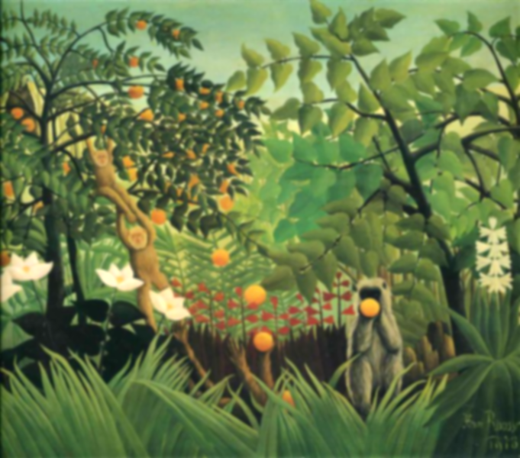

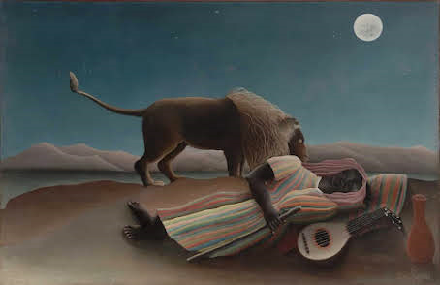

**Final Piece: Create a scene, inspired by The Great Kapok Tree and ‘Tiger in a Tropical Storm.’**

I can create a painting in the style of Henri Rousseau.

* Revise discussion of ‘Tiger in a Tropical Storm – colours used, details, atmosphere, etc.
* Identify the subject (animal) and the setting (jungle) and discuss what similar creatures we find in the text the Great Kapok Tree.
* Sketch a scene, using photographs, the text and Rousseau as inspiration.
* Paint the scene using washes, details.
* Use collage layers, like The Sleeping Gypsy, for the more able.
* ***Critique your work. How is it similar/different to Rousseau’s? Do you like this style? Why?***

**Learning point 4: dots, dabs and dashes**

I can create detail using fine brushes.

* Look at Tiger in a Tropical Storm and other similar works. Discuss it. What details can you see? Highlight to rain, the ferns, the lines on the leaves, etc.
* Practice adding detail by using dots, dashes and dabs to washes using a fine brush.
* Identify where each technique can be used in a painting and decide the techniques that the children like best to use in a final piece.

***Add detail to washes of watercolour, using watercolour or poster paint, to create foliage and rain effects.***

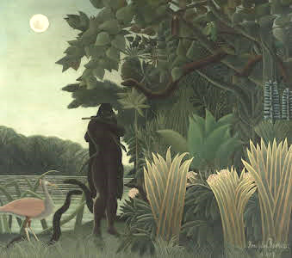

**Henri Rousseau**

**Tiger in a Tropical Storm**

**Vocabulary**

**Complimentary Colours:** colours opposite each other on the colour wheel

**Washes:** large areas of colour.

**Watercolour:** a water-based paint.

**Collage:** 2D layers built upon in different media.

**Justify:** prove your reasoning.

**Learning point 1: Artist research**

I can find out about a famous artist.

* Look closely at some of the works of Henri Rousseau.
* Discuss his life and what inspired him to start painting.
* Discuss how his paintings make you feel.
* Record some of this information in a sketchbook.

***What are some of Rousseau’s best-known works.***

**Previous Knowledge**

* Understanding of primary and secondary colours.
* Thick brushes can add washes and thin brushes can be used for detail.
* Cleaning brushes between colours.

**Learning point 3: Washes, shading and shadows**

I can use washes to enhance my painting.

* Use thick brushes to make washes for a painting of a simple landscape scene.
* Add some detail with watercolour, then add a darker wash to add shadows and shading.
* Use lighter colours on top to add detail using a thin brush.

***Look at ‘The Snake charmer’ and create washes for shading and shadows.***

**Learning point 2: Complimentary colours**

I can identify complimentary colours.

* Use the colour wheel and identify the primary and secondary colours.
* Identify opposite colours as complimentary colours.
* Discuss a primary colour, then mix the remaining two to make the complimentary colour.

***Look at ‘A Centennial of Independence’ and mix complimentary colours to recreate characters using poster paint.***

