Key Knowledge |  | Detail
Paintings can tell a story | Children to understand that a painting can tell a story through the different features, colours or shapes. The stories may be inspired by the artists lives, nature, historical events – a broad list.
Art can be used to evoke emotion or show emotion | Different colours, shapes and objects can be used to either present how the artist or a character in the painting is feeling or to evoke a feeling from the person viewing the painting.
Roman artwork | The art of the Roman Empire includes architecture, painting, sculpture and mosaic work. Wealthy people had mosaic floors in their homes.  Mosaics in Britain were made from cut red brick or tile. Occasionally, they might use bits of glass for a particular effect. Mosaics featured geometric designs, as well as other images. Common themes were animals, fighting gladiators, romantic images and scenes from mythology and astronomy.
LKS2 Art KCV – Spring term 23/24
High frequency vocabulary
Abstract | Mosaic
Narrative | Sculpture
Pop art | Architecture
Preparatory drawing | Painting
Re-enact | Border
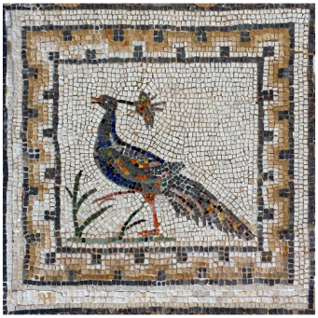
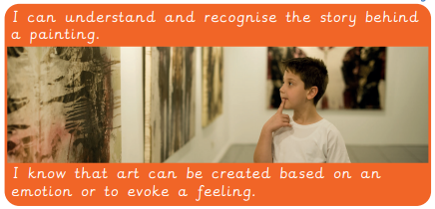
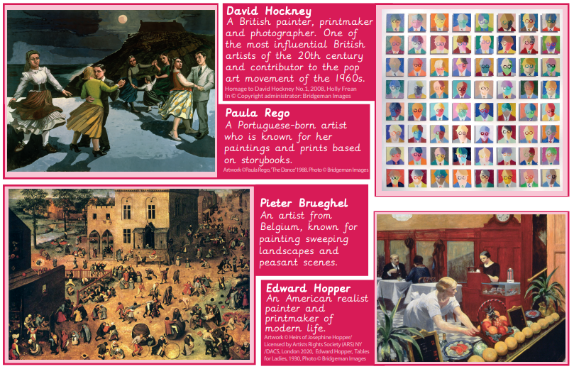
Key questions
How can we analyse a famous painting?
How can we find meaning in painting?
How can we consider another perspective?
How did the Romans use artwork?
How do artists use art to tell or evoke feelings?

